INCIDENT INTELLIGENCE AND ESCALATION PLATFORM
A PROJECT REPORT
Submitted by
ROSHNI R
(240701443)
in partial fulfilment of the End Semester Examination for the course
CB23F35 –
LOW-CODE APPLICATION DEVELOPMENT USING ZOHO CREATOR
in
BACHELOR OF ENGINEERING
COMPUTER SCIENCE AND ENGINEERING

RAJALAKSHMI ENGINEERING COLLEGE
(An Autonomous Institution, Affiliated to Anna University, Chennai)
Rajalakshmi Nagar, Thandalam, Tamil Nadu – 602 105
NOVEMBER 2026

RAJALAKSHMI ENGINEERING COLLEGE
(An Autonomous Institution, Affiliated to Anna University, Chennai)
BONAFIDE CERTIFICATE
CB23F35 – LOW-CODE APPLICATION DEVELOPMENT USING ZOHO CREATOR
SIGNATURE  Name: ____________________  HEAD OF THE DEPARTMENT  Department of Computer Science and Engineering  Rajalakshmi Engineering College  Thandalam – 602 105 | SIGNATURE  Name: ____________________  COURSE FACULTY  Course Faculty  Department of Computer Science and Engineering  Rajalakshmi Engineering College

Submitted for the End Semester Examination (Individual Project) held on 02 November 2026.
INTERNAL EXAMINER | EXTERNAL EXAMINER

DECLARATION
CB23F35 – LOW-CODE APPLICATION DEVELOPMENT USING ZOHO CREATOR
I further declare that this work has not been submitted, in part or in full, for the award of any other degree or course credit. Every template, sample application, AI-assisted feature (such as Zia or the AI application builder), code snippet or external resource used in this work has been duly acknowledged in the report.
Place: Chennai SIGNATURE OF THE STUDENT
Date: 02 November 2026 ROSHNI R
240701443

ACKNOWLEDGEMENT

I express my sincere gratitude to the management of Rajalakshmi Engineering College for providing the academic environment and infrastructure required to complete this project.
I thank the Principal of Rajalakshmi Engineering College for the encouragement extended to students to undertake practical and industry-oriented learning.
I express my gratitude to the Head of the Department, Department of Computer Science and Engineering, for the support and facilities provided during the course.
I sincerely thank the course faculty for the guidance, reviews and feedback provided throughout the design and development of this application.
I acknowledge Zoho Corporation for the Zoho Creator platform and its learning resources. I also thank my family and friends for their encouragement and support.

ROSHNI R

ABSTRACT

Cybersecurity incidents such as suspicious logins, unauthorized access, malware alerts and service disruptions must be recorded and handled in a consistent manner. In small teams and academic environments, incident details are often shared through messages, calls or separate spreadsheets. This fragmented approach can result in incomplete records, unclear ownership, delayed escalation and difficulty identifying incidents that have exceeded their response targets.
The Incident Intelligence and Escalation Platform was developed as a low-code application using Zoho Creator. It contains Incident Report, Incident Investigation and Incident Resolution forms linked through lookup fields. A Deluge form workflow maps severity to priority and calculates an SLA deadline. Investigation records capture analyst assignment, risk score and notes. A Blueprint defines New, In Progress, Escalated and Resolved stages. An escalation workflow sends an email when the escalation checkbox is selected, while reports and dashboard charts provide operational visibility.
Functional checks confirmed priority and SLA population for tested critical and high incidents, delivery of the escalation email when selected, and display of incident counts in the dashboard. The overdue-check function was executed and returned records matching its unresolved-and-past-deadline condition. Full multi-role access verification and recurring schedule configuration remain pending and are reported as limitations rather than completed outcomes. The prototype demonstrates how low-code forms, scripts and process controls can centralize incident handling.
Keywords: Low-Code Development; Zoho Creator; Cybersecurity Incident Management; Deluge Scripting; SLA Monitoring; Workflow Automation

PROJECT AT A GLANCE

Attribute | Details
Project Title | Incident Intelligence and Escalation Platform
Application Domain | Cybersecurity Incident Management
Student Name & Register No. | Roshni R – 240701443
Course | CB23F35 – Low-Code Application Development using Zoho Creator
Platform | Zoho Creator
Primary Forms | Incident Report; Incident Investigation; Incident Resolution
Reports | All Incident Reports; Critical Incidents; Open Incidents; Investigation; Resolution
Automation | Priority/SLA workflow; escalation email; SLA breach function
Blueprint | New → In Progress → Escalated / Resolved
Dashboard | Incident Status Overview and incident analysis charts
Testing Status | Selected functional checks completed; role/schedule verification pending
Application Type | Individual academic prototype
Department | Computer Science and Engineering
Institution | Rajalakshmi Engineering College
Academic Year | 2026–2027
Project Author | Roshni R

TABLE OF CONTENTS
Formatting Standards (Anna University Convention) 1
Working with the Template 1
ABSTRACT iv
PROJECT AT A GLANCE v
LIST OF TABLES ix
LIST OF FIGURES x
LIST OF ABBREVIATIONS xi
INTRODUCTION 1
1.1 Background 1
1.2 Problem Statement 1
1.3 Objectives 1
1.4 Scope of the Project 1
1.5 Justification for a Low-Code Approach 2
1.6 Organisation of the Report 2
LITERATURE SURVEY AND SYSTEM STUDY 3
2.1 Study of the Existing System 3
2.2 Limitations of the Existing System 3
2.3 Low-Code versus Traditional Development 3
2.4 Literature Survey 4
2.5 Emerging Trends in Low-Code Development 4
2.6 Proposed System 4
REQUIREMENT ANALYSIS 5
3.1 Stakeholders and User Roles 5
3.2 Functional Requirements 5
3.3 Non-Functional Requirements 5
3.4 Hardware and Software Requirements 6
3.5 Use Case Model 6
SYSTEM DESIGN 8
4.1 System Architecture 8
4.2 Data Model 8
4.3 Form Design 9
4.4 Process and Workflow Design 9
4.5 User Interface and Navigation Design 10
4.6 Access Control Design 10
IMPLEMENTATION 11
5.1 Application Setup 11
5.2 Forms and Data Capture 11
5.3 Reports 12
5.4 Pages and Dashboards 13
5.5 Deluge Scripting 13
5.6 Workflows and Automation 14
5.7 Integrations 15
5.8 User Management and Role-Based Access 16
5.9 AI and Analytics Features 16
5.10 Pro-Code Extension 17
5.11 Mobile and Portal Access 17
TESTING AND DEBUGGING 18
6.1 Testing Strategy 18
6.2 Test Cases 18
6.3 Debugging Deluge Scripts 18
6.4 Defect Log 19
6.5 User Acceptance Testing 19
DEPLOYMENT, SECURITY AND GOVERNANCE 20
7.1 Environments and Deployment Strategy 20
7.2 Performance Optimisation 20
7.3 Security Features 21
7.4 Governance and Administration 21
RESULTS AND DISCUSSION 22
8.1 Application Output 22
8.2 Achievement of Objectives 23
8.3 Comparison with the Existing System 23
8.4 Limitations of the Low-Code Approach 23
8.5 Reflection on the No-Code → Low-Code → Pro-Code Spectrum 23
CONCLUSION AND FUTURE ENHANCEMENTS 24
9.1 Conclusion 24
9.2 Future Enhancements 24
9.3 Learning Outcomes and Career Relevance 24
REFERENCES 25
APPENDIX A – ZOHO CREATOR FEATURE COVERAGE CHECKLIST 26
APPENDIX B – COURSE OUTCOME MAPPING 28
APPENDIX C – COMPLETE DELUGE SOURCE CODE 29
APPENDIX D – USER MANUAL 30
D.1 Accessing the Application 30
D.2 Instructions for [Role 1] 30
D.3 Instructions for [Role 2] 30
APPENDIX E – EVALUATION RUBRIC 31
APPENDIX F – VIVA-VOCE RECORD SHEET 33

LIST OF TABLES
Table 2.1: Comparison of Low-Code and Traditional Development for the Proposed Application 3
Table 2.2: Summary of Literature Survey 4
Table 3.1: Stakeholders and User Roles 5
Table 3.2: Functional Requirements 5
Table 3.3: Non-Functional Requirements 5
Table 3.4: Hardware and Software Requirements 6
Table 3.5: Use Case Description – [Use Case Name] 6
Table 4.1: Entities and Relationships 9
Table 4.2: Field Specification – [Form Name] Form 9
Table 4.3: Role–Permission Matrix 10
Table 5.1: Reports Implemented 12
Table 5.2: Deluge Scripts Implemented 13
Table 5.3: Workflows Implemented 14
Table 5.4: Integrations Implemented 15
Table 6.1: Test Cases 18
Table 6.2: Defect Log 19
Table 6.3: User Acceptance Feedback 19
Table 7.1: Deployment Checklist 20
Table 7.2: Performance Optimisation Results 20
Table 7.3: Security Controls Implemented 21
Table 8.1: Mapping of Objectives to Outcomes 23
Table 8.2: Existing System versus Proposed Application 23
Table A.1: Feature Coverage Checklist 26
Table B.1: Mapping of Course Outcomes to Report Chapters 28
Table E.1: Evaluation Rubric for the Individual Project 31
Table E.2: Performance Level Descriptors 32
Table F.1: Viva-Voce Questions and Responses 33
Table F.2: Marks Summary 33

LIST OF FIGURES
Figure 2.1: Existing Incident Reporting Process 3
Figure 3.1: Use Case Model of the Incident Platform 6
Figure 4.1: System Architecture of the Application 8
Figure 4.2: Entity–Relationship Diagram 8
Figure 4.3: Workflow / Process Flow for Incident Handling 10
Figure 4.4: Navigation Structure and Wireframe of Incident Dashboard 10
Figure 5.1: Incident Intelligence Application Home 11
Figure 5.2: Incident Report Form in the Form Builder 11
Figure 5.3: Incident Report Form in Live Mode 12
Figure 5.4: Critical Incidents Report 12
Figure 5.5: Incident Status Overview Dashboard 13
Figure 5.6: Incident Investigation Blueprint Configuration 15
Figure 5.7: Escalation Email Notification Workflow 16
Figure 5.8: Roles and Permission Profiles 16
Figure 5.9: Incident Analytics and Dashboard Chart 17
Figure 5.10: Incident Review and Resolution Interface 17
Figure 6.1: SLA Breach Function Execution 19
Figure 7.1: Zoho Creator Application Deployment 20
Figure 7.2: Administration and Configuration Settings 21
Figure 8.1: Scenario Step 1 – Incident Submission 22
Figure 8.2: Scenario Step 2 – Incident Investigation and Escalation 22
Figure 8.3: Scenario Step 3 – Incident Resolution and Reporting 22

LIST OF ABBREVIATIONS

Abbreviation | Expansion
API | Application Programming Interface
CRUD | Create, Read, Update, Delete
ER | Entity–Relationship
FR | Functional Requirement
NFR | Non-Functional Requirement
RBAC | Role-Based Access Control
SLA | Service Level Agreement
UI | User Interface
UAT | User Acceptance Testing
SOC | Security Operations Centre
SIEM | Security Information and Event Management
ID | Identifier
URL | Uniform Resource Locator
Zoho | Zoho Corporation platform

CHAPTER 1

INTRODUCTION

Background
Cybersecurity incident management is the process of recording, analysing, responding to and closing events that may affect the confidentiality, integrity or availability of information systems. The proposed application is intended for a small IT support or security operations team. Reporters submit an incident, analysts investigate it, and managers review escalations and overall workload. A centralized record is important because incident details, severity, assigned analyst, deadlines and resolution actions must remain traceable throughout the response lifecycle.

Problem Statement
The project addresses the absence of a centralized, structured and workflow-driven process for handling cybersecurity incidents. When incident reports are maintained through informal communication or disconnected spreadsheets, teams may lose track of severity, responsibility, deadlines and resolution history. The proposed Zoho Creator application organizes these activities in linked forms and automates selected decisions through Deluge workflows.
- Incident details may be incomplete or duplicated across separate communication channels.
- Manual prioritization and deadline tracking can cause inconsistent handling and missed SLA targets.
- Limited status visibility makes investigation ownership, escalation and reporting difficult.

Objectives
- To design linked forms for incident reporting, investigation and resolution.
- To automate severity-based priority assignment and SLA deadline calculation using Deluge.
- To provide filtered incident reports and dashboard charts for status and severity monitoring.
- To configure email notification for incidents marked as requiring escalation.
- To configure roles, permission profiles and a repeatable deployment and verification process.

Scope of the Project
The scope includes incident intake, severity classification, priority and SLA calculation, investigation tracking, escalation notification, resolution records, Blueprint transitions, filtered reports and dashboard charts in Zoho Creator. Reporter, Security Analyst and Security Manager roles were created in the role hierarchy, but end-to-end role assignment and permission isolation require further verification. Out of scope are automated threat detection, packet inspection, malware analysis, SIEM integration and automatic containment.

Justification for a Low-Code Approach
Zoho Creator is suitable because the application primarily requires structured forms, lookup relationships, filtered reports, dashboards and event-driven workflows. The visual builder reduces the amount of infrastructure code needed, while Deluge supports the conditional logic for priority, deadlines and notifications. The platform also provides built-in application hosting and user-management features. This low-code approach is appropriate for a focused prototype that can be maintained through visual configuration and small scripts [1], [2].

Organisation of the Report
Chapter 2 reviews the existing system and related low-code literature. Chapter 3 presents the requirement analysis. Chapter 4 describes the system design. Chapter 5 details the implementation on Zoho Creator. Chapter 6 covers testing and debugging. Chapter 7 discusses deployment, performance optimisation, security and governance. Chapter 8 presents results and discussion, and Chapter 9 concludes the report with future enhancements.
CHAPTER 2

LITERATURE SURVEY AND SYSTEM STUDY

2.1 Study of the Existing System
In a manual process, a user notices a possible security event and informs an IT contact through a call, email or chat. The receiver records the details in a spreadsheet or ticket, decides the urgency, contacts an analyst and follows up manually. Investigation notes may be stored separately. If the incident requires escalation, a manager is contacted manually. At the end, the resolution is recorded in the same or another document. Reports are compiled by filtering or counting rows.

Existing process: Report event → Record manually → Assign by communication → Investigate separately → Contact manager if needed → Close record.
Figure 2.1: Existing Incident Reporting Process
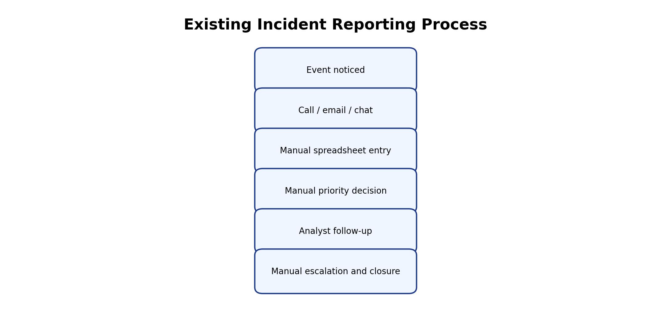

2.2 Limitations of the Existing System
- No single structured record connects incident intake, investigation and resolution.
- Priority and response deadlines depend on manual judgement and follow-up.
- Escalation notifications and management reporting are not consistently automated.

2.3 Low-Code versus Traditional Development
Table 2.1: Comparison of Low-Code and Traditional Development for the Proposed Application
Criterion | Traditional (Pro-Code) Development | Low-Code on Zoho Creator
Development time | Requires coding forms, backend, UI and hosting separately | Visual form, report and workflow builders accelerate setup
Skills required | Frontend, backend, database and deployment skills | Creator configuration and Deluge knowledge
Hosting & infrastructure | Application hosting and database must be arranged | Creator provides hosted application environment
Workflow implementation | Custom backend logic and notification services | Built-in workflows and Deluge
Maintenance | Code changes and deployment pipeline | Visual configuration with script updates
Customisation | Flexible but requires development effort | Platform capabilities and Deluge boundaries
Cost | Depends on infrastructure and developer effort | Depends on Creator plan and user licensing
Incident visibility | Must build reporting interface | Reports and dashboard components are built in

2.4 Literature Survey
Table 2.2: Summary of Literature Survey
S.No. | Author(s) / Source & Year | Title / Product | Key Findings | Relevance to this Project
1 | NIST, 2012 | Computer Security Incident Handling Guide, SP 800-61 Rev. 2 | Incident response requires preparation, detection, analysis, containment and recovery. | Supports lifecycle-based incident workflow.
2 | NIST, 2024 | Cybersecurity Framework 2.0 | Provides outcomes for governance, identification, protection, detection, response and recovery. | Supports structured response and governance.
3 | Zoho Corporation | Zoho Creator Help Documentation | Documents forms, reports, pages, workflows and application configuration. | Platform implementation reference.
4 | Zoho Corporation | Deluge Script Reference | Describes syntax, conditions, collections, date functions and sendmail. | Supports priority, SLA and notification scripts.
5 | ISO/IEC, 2016 | ISO/IEC 27035-1: Information Security Incident Management | Describes principles for incident management processes. | Supports incident management concepts.

2.5 Emerging Trends in Low-Code Development
Low-code platforms increasingly combine visual application building with workflow automation, reusable components and AI-assisted development. For this project, the most relevant trend is hyper-automation: form submission, priority calculation, deadline assignment, escalation notification and reporting are connected as a single process. AI-assisted application building may accelerate initial design, but all generated fields, scripts and permissions still require human validation. The prototype uses deterministic Deluge rules rather than claiming predictive AI capability.

2.6 Proposed System
The proposed system centralizes the incident lifecycle in Zoho Creator. Incident Report is the primary record. Incident Investigation and Incident Resolution link to it through lookup fields. A Deluge workflow maps Critical, High, Medium and Low severity to matching priority and SLA targets of 4, 8, 24 and 48 hours. A Blueprint supports New, In Progress, Escalated and Resolved stages. An escalation checkbox triggers an email notification. Reports and charts summarize the stored records.
CHAPTER 3

REQUIREMENT ANALYSIS

3.1 Stakeholders and User Roles
Table 3.1: Stakeholders and User Roles
Role | Description | Key Responsibilities in the Application
Reporter | Person who identifies and submits an incident. | Create incident records; provide accurate details; view permitted records.
Security Analyst | Person responsible for investigation. | Review incidents; create investigation records; record risk score and notes; update workflow stage.
Security Manager | Person responsible for oversight and escalation. | Review escalated incidents; monitor reports and dashboard; coordinate resolution.
Administrator | Application configuration role. | Maintain forms, workflows, reports, permissions and application settings.

3.2 Functional Requirements
Table 3.2: Functional Requirements
FR ID | Requirement | Role(s) | Priority
FR-01 | The system shall allow a reporter to submit an incident with type, description, severity and affected system. | Reporter | High
FR-02 | The system shall generate a unique incident identifier for each incident record. | System | High
FR-03 | The system shall assign priority and calculate an SLA deadline from severity. | System | High
FR-04 | The system shall allow an analyst to create an investigation linked to an incident. | Analyst | High
FR-05 | The system shall store analyst assignment, risk score and investigation notes. | Analyst | High
FR-06 | The system shall support investigation stages New, In Progress, Escalated and Resolved. | Analyst / Manager | High
FR-07 | The system shall send an email when Escalation Required is selected in a resolution record. | System | High

3.3 Non-Functional Requirements
Table 3.3: Non-Functional Requirements
NFR ID | Category | Requirement
NFR-01 | Usability | Forms shall use clear labels and structured field types.
NFR-02 | Data integrity | Investigation and resolution records shall link to a valid incident record.
NFR-03 | Maintainability | Priority and SLA rules shall be maintained in a Deluge workflow.
NFR-04 | Availability | The application shall be accessible through the Zoho Creator hosted environment, subject to service availability.
NFR-05 | Security | Users shall access only data and actions permitted by configured roles and permissions.
NFR-06 | Traceability | Incident status, investigation notes and resolution details shall be stored as records.

3.4 Hardware and Software Requirements
Table 3.4: Hardware and Software Requirements
Category | Specification
Platform | Zoho Creator web application
Scripting language | Deluge
Browser | Recent version of Google Chrome / Microsoft Edge
Operating system | Windows 10/11 or supported desktop OS
Network | Internet connection for hosted Zoho Creator access
Development tools | Zoho Creator Form, Report, Page, Workflow and Blueprint builders
User device | Desktop or laptop for configuration and testing

3.5 Use Case Model

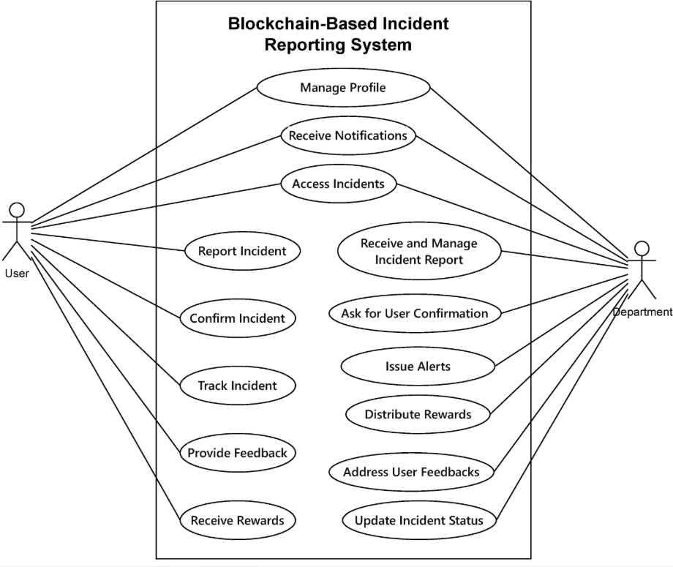
Figure 3.1: Use Case Model of the Incident Platform
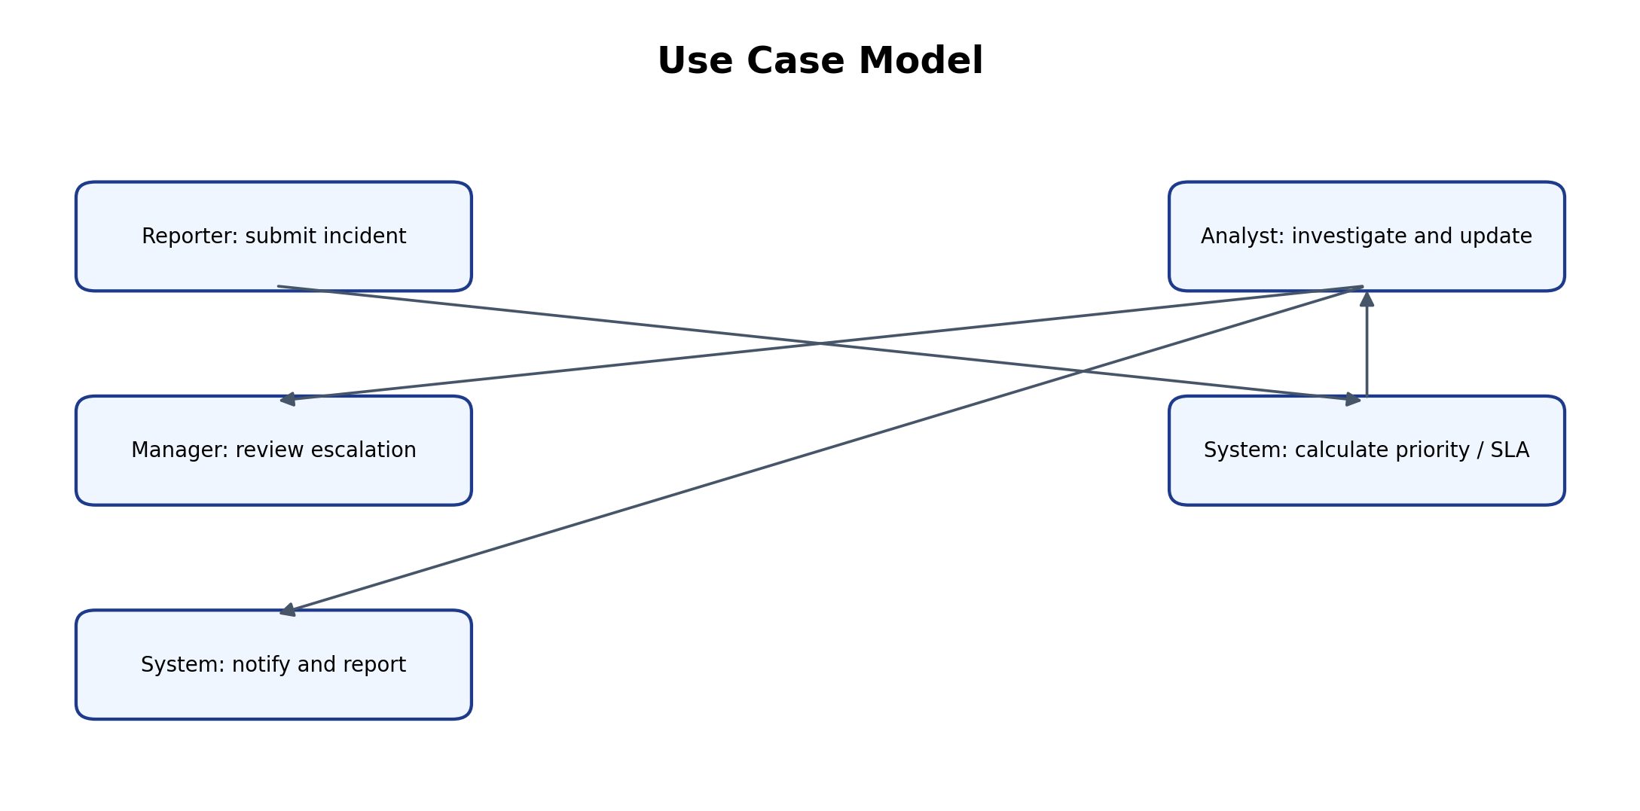
Table 3.5: Use Case Description – Submit and Investigate Incident
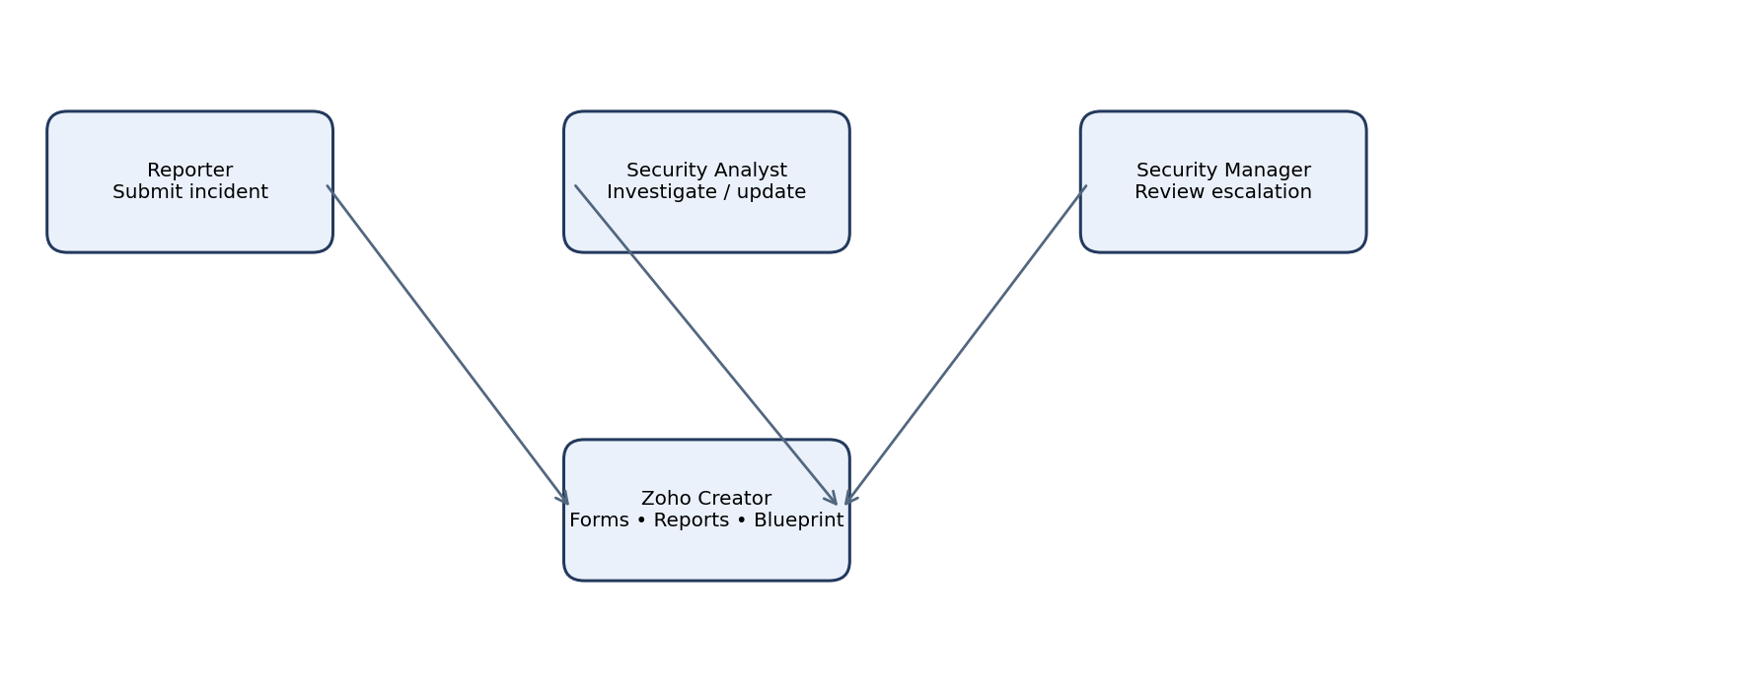 | UC-01
Use Case Name | Report a cybersecurity incident
Actor(s) | Reporter
Pre-condition | Reporter has access to the application.
Main Flow | Reporter opens Incident Report form.
Alternate Flow | Incident details are entered and submitted.
Post-condition | A new incident record is stored with generated Incident ID.
Related FR | Priority and SLA workflow executes from selected severity.
CHAPTER 4

SYSTEM DESIGN

4.1 System Architecture

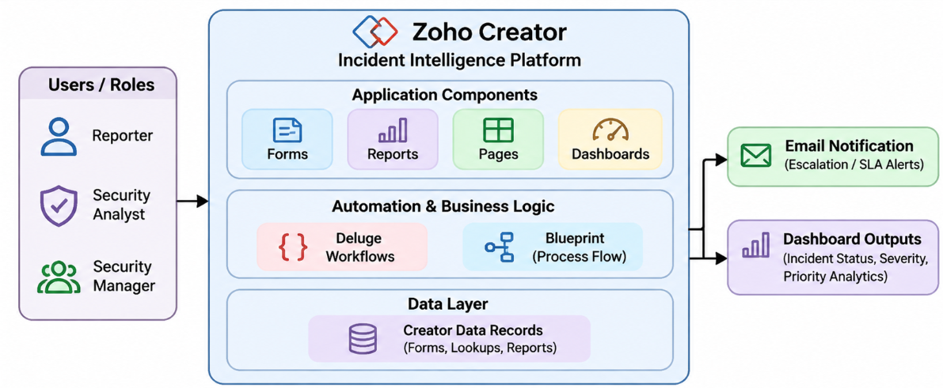
Figure 4.1: Architecture of the Incident Intelligence Platform
Users interact with Zoho Creator forms and pages. Form records are stored in the Creator application data layer. Lookup fields connect investigation and resolution records to the original incident. Deluge workflows implement priority, deadline and notification logic. Blueprint controls the investigation lifecycle. Reports and dashboard components read the stored data and present filtered lists and visual summaries.

4.2 Data Model

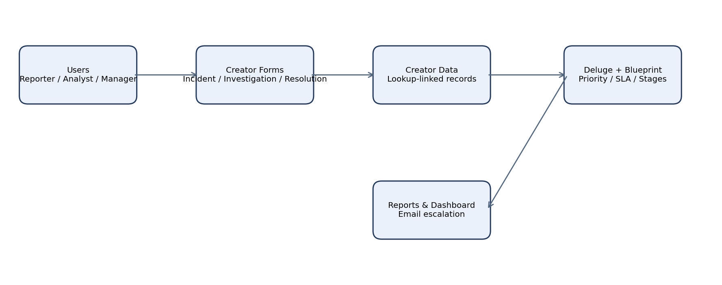
Figure 4.2: Entity–Relationship Model
Table 4.1: Entities and Relationships
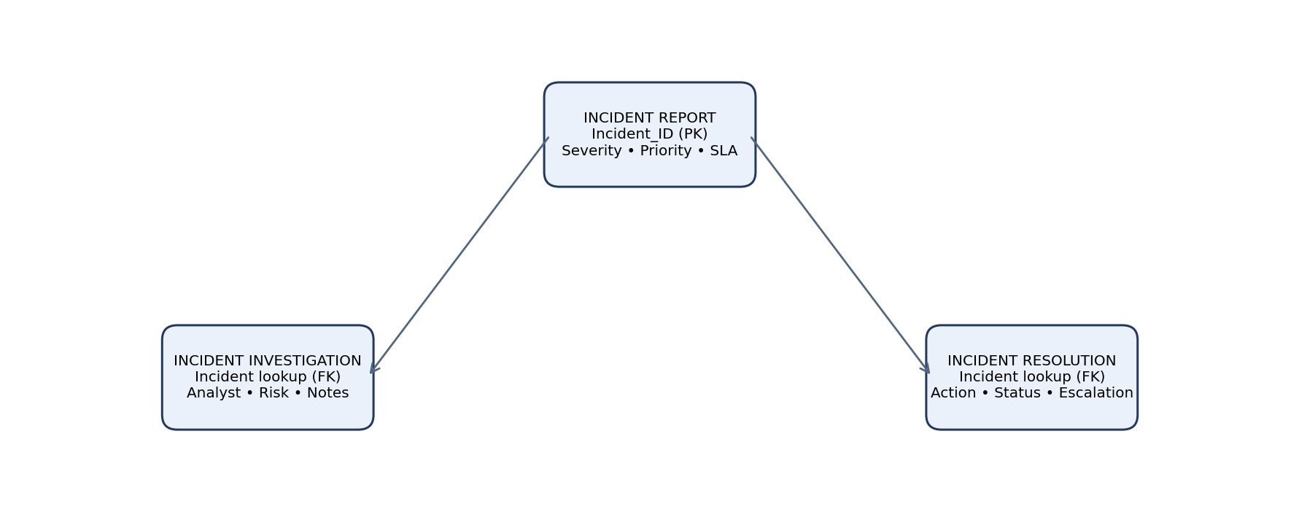 | Key Fields | Related To | Relationship Type | Implemented Using
Incident Report | Incident_ID, Reporter_Name, Incident_Type, Description, Severity, Status, Priority, SLA_Deadline | Incident Investigation | One-to-many conceptually | Lookup in Incident Investigation
Incident Report | Incident_ID, Severity, Status | Incident Resolution | One-to-many conceptually | Lookup in Incident Resolution
Incident Investigation | Assigned_Analyst, Risk_Score, Investigation_Notes | Incident Report | Many-to-one | Incident Report lookup
Incident Resolution | Action_Taken, Resolution_Status, Escalation_Required, Escalation_Reason | Incident Report | Many-to-one | Incident Report lookup

4.3 Form Design
Table 4.2: Field Specification – Incident Report Form
Field Label | Link Name | Field Type | Mandatory | Validation / Default | Remarks
Incident ID | Incident_ID | Auto Number | System | Auto generated | Primary incident identifier
Reporter Name | Reporter_Name | Single Line | Yes | User-entered | Reporter identity
Incident Type | Incident_Type | Dropdown | Yes | Configured options | Incident category
Description | Description | Multi Line | Yes | User-entered | Incident details
Severity | Severity | Dropdown | Yes | critical / high / medium / low | Drives priority and SLA
Affected System | Affected_System | Single Line | Yes | User-entered | Impacted asset
Status | Status | Dropdown | Yes | New / In Progress / Resolved | Incident state
Priority | Priority | Dropdown | Workflow-populated | critical / high / medium / low | Derived from severity
SLA Deadline | SLA_Deadline | Date-Time | Workflow-populated | Current time + severity target | Target deadline

4.4 Process and Workflow Design

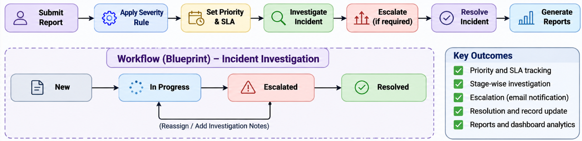
Figure 4.3: Workflow / Process Flow for Incident Handling
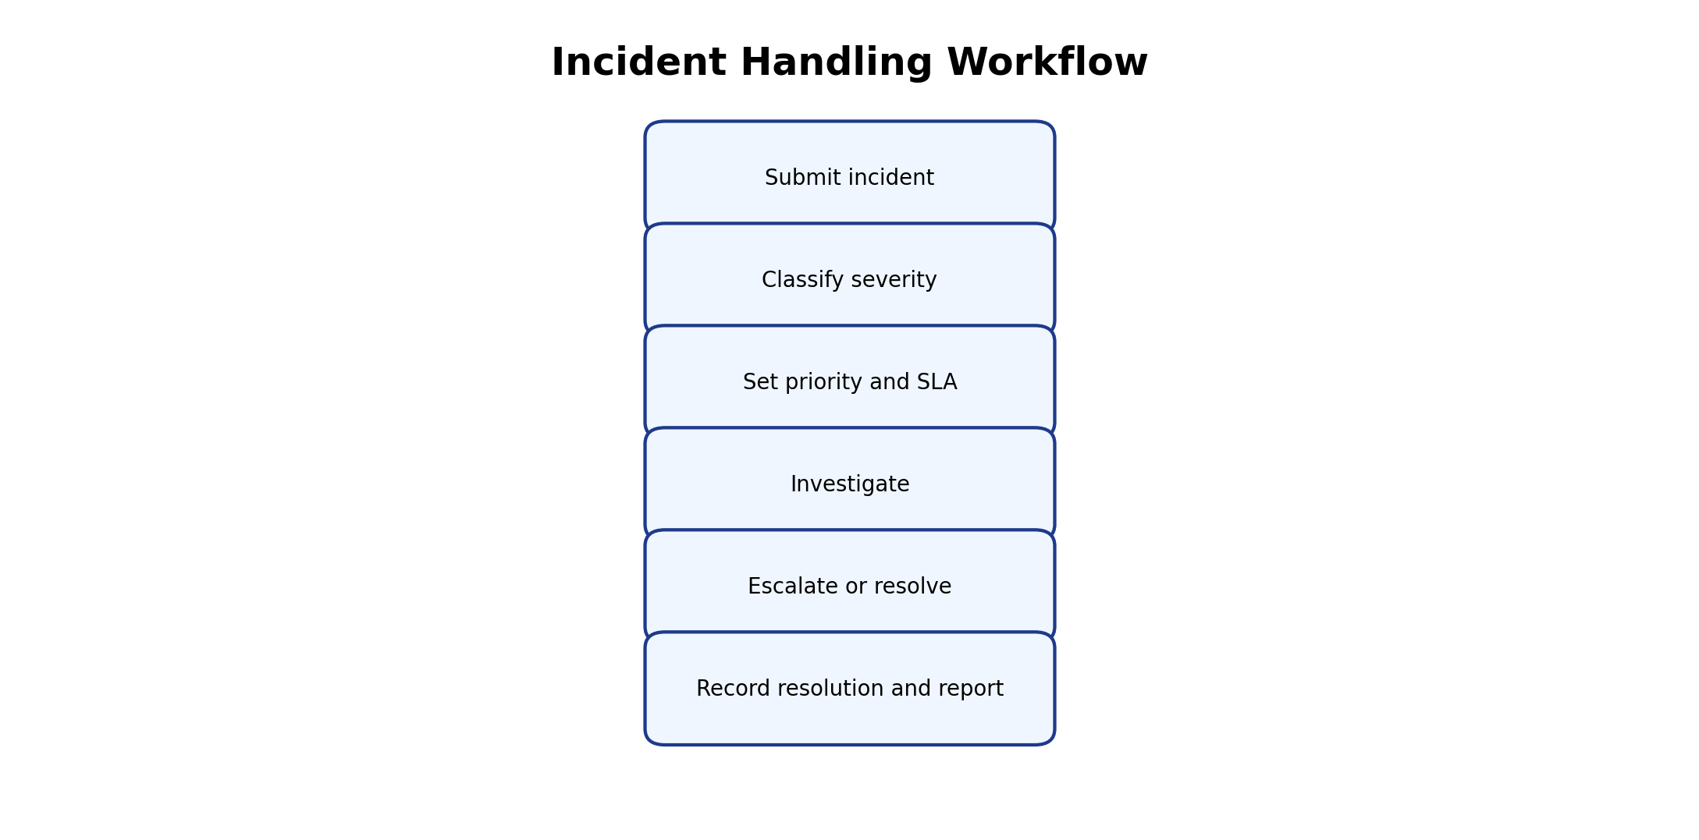

4.5 User Interface and Navigation Design

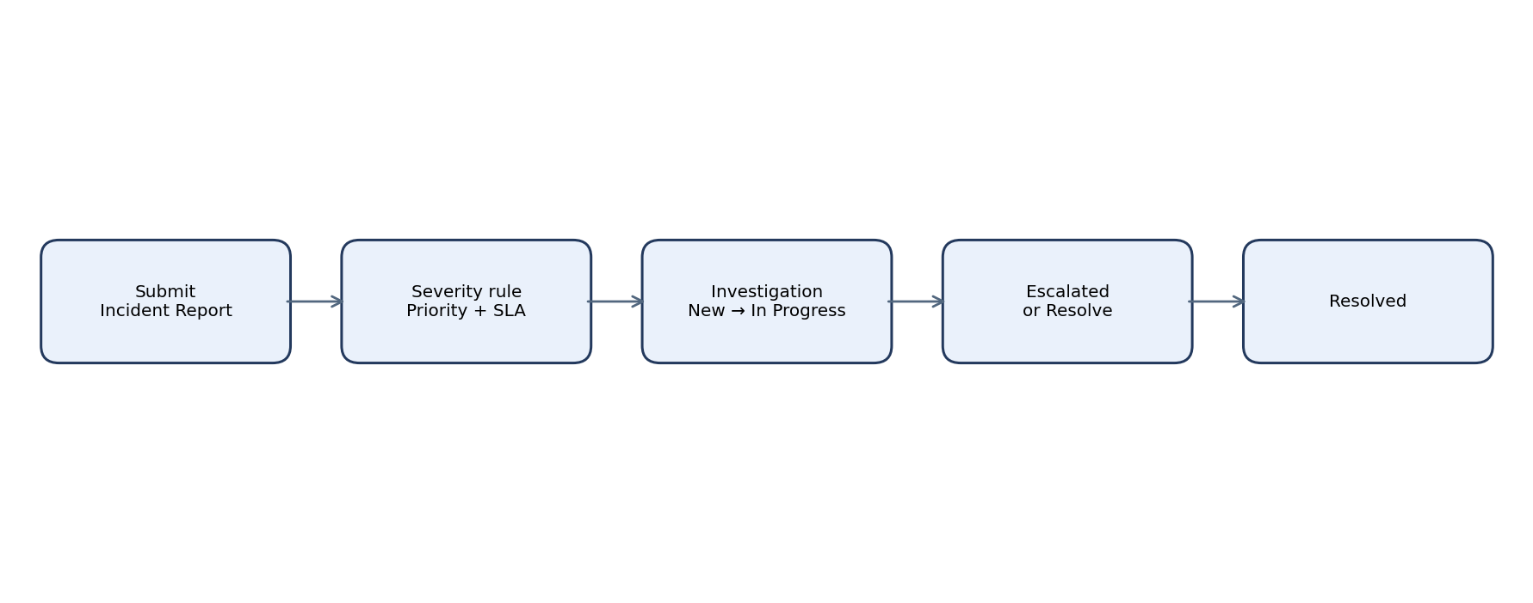
Figure 4.4: Navigation Structure and Wireframe of Incident Dashboard

4.6 Access Control Design
Table 4.3: Role–Permission Matrix
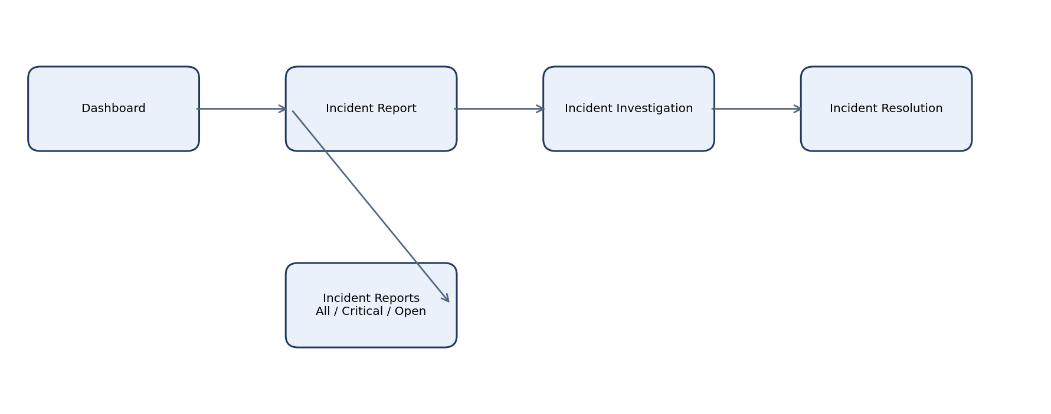 | Reporter | Security Analyst | Security Manager | Administrator
Incident Report Form | A / V (own) | V | V | A / E / V / D
Incident Investigation Form | — | A / E / V | V | A / E / V / D
Incident Resolution Form | — | A / E / V | A / E / V | A / E / V / D
Reports / Dashboard | V (permitted) | V | V | V
Role assignment | — | — | — | Configure
CHAPTER 5

IMPLEMENTATION

5.1 Application Setup
The application was created in Zoho Creator using the visual application builder. The forms were created first, followed by lookup relationships, reports, dashboard charts, Deluge workflows and the investigation Blueprint. The application uses the Zoho Creator hosted environment. The prototype was tested using manually entered incident records.

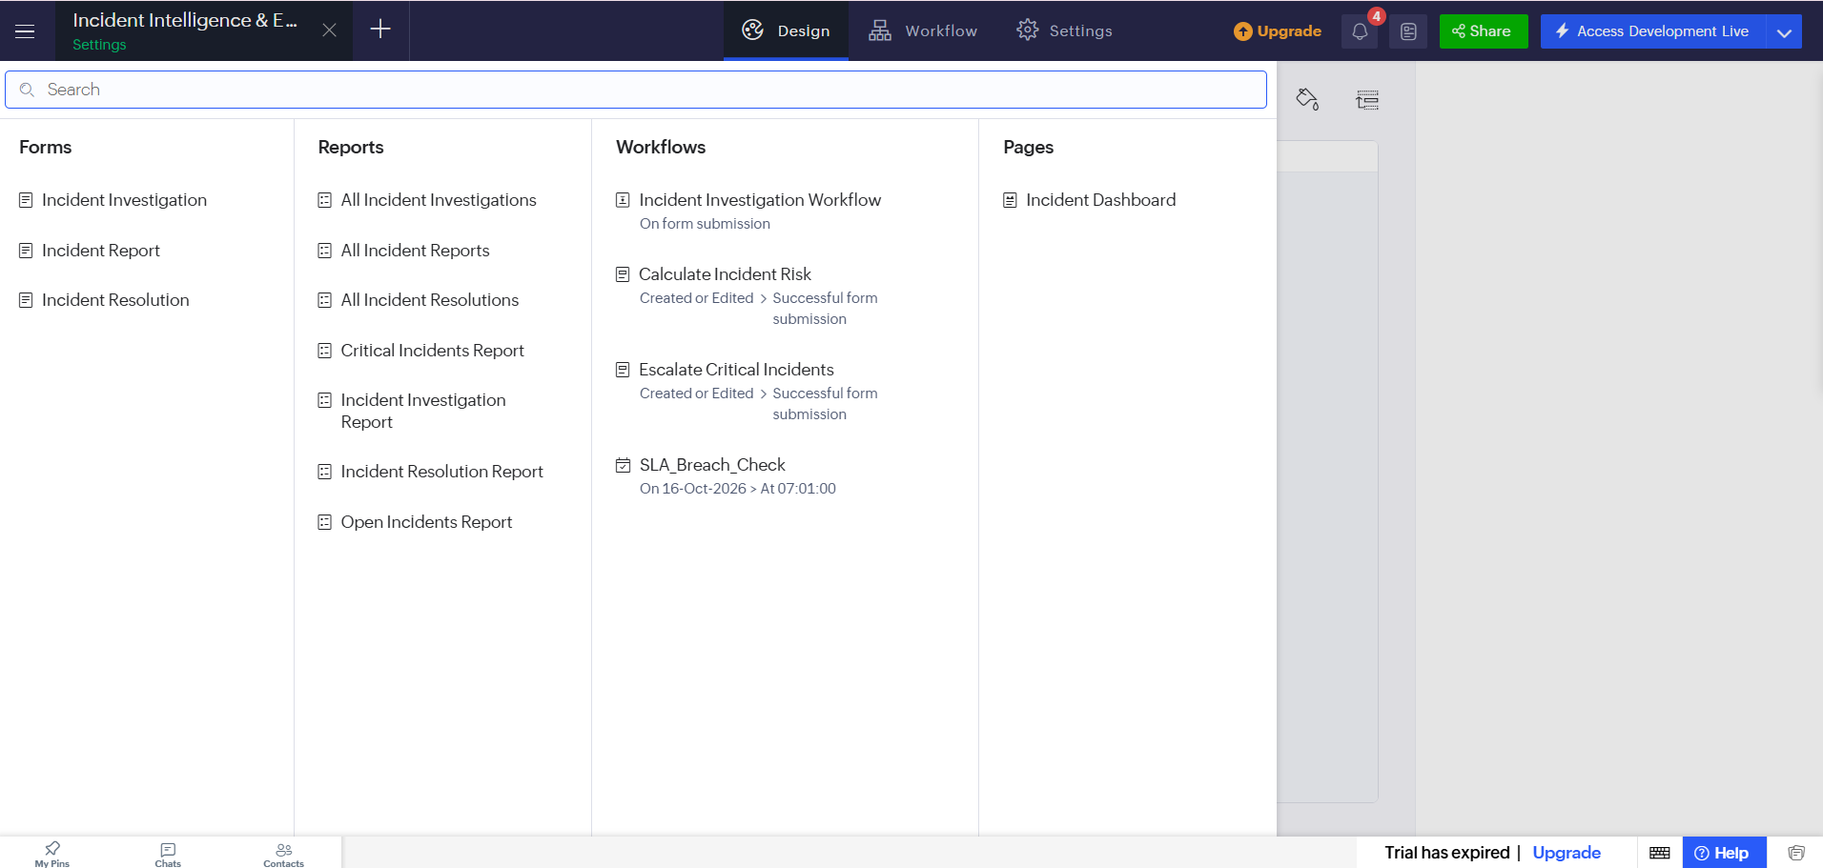
Figure 5.1: Application Home and Navigation Sections
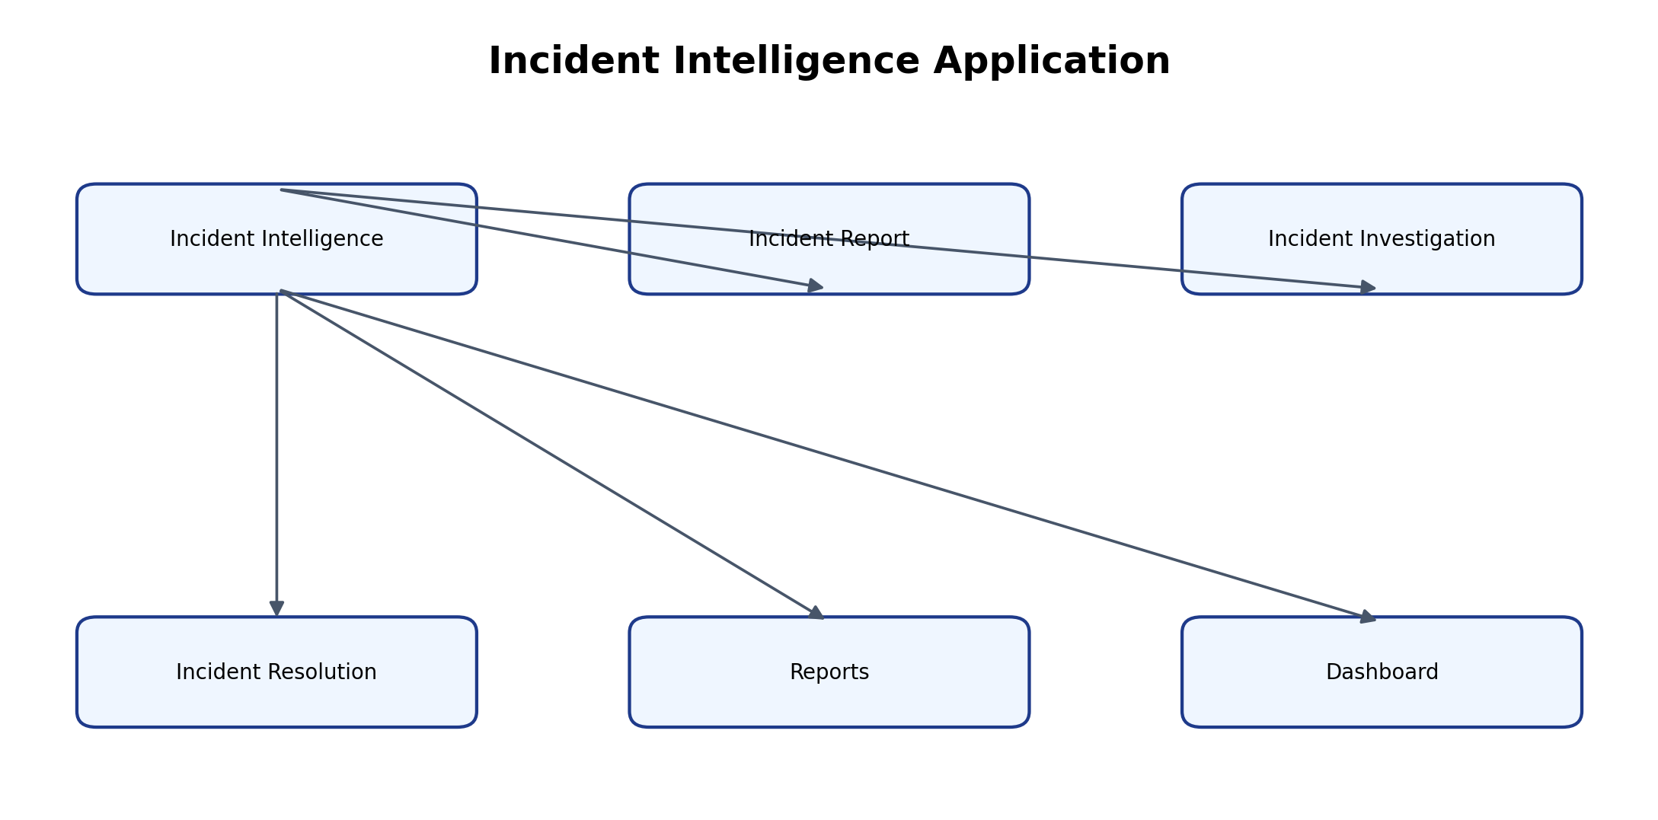

5.2 Forms and Data Capture
Three forms were implemented. Incident Report captures the auto-generated Incident ID, reporter name, incident type, description, severity, affected system, status, priority and SLA deadline. Incident Investigation links to the incident and captures Assigned Analyst, Risk Score, Priority, SLA Deadline and Investigation Notes. Incident Resolution links to the incident and captures Action Taken, Resolution Status, Escalation Required and Escalation Reason. The lookup fields preserve the relationship between the primary incident and its operational records.

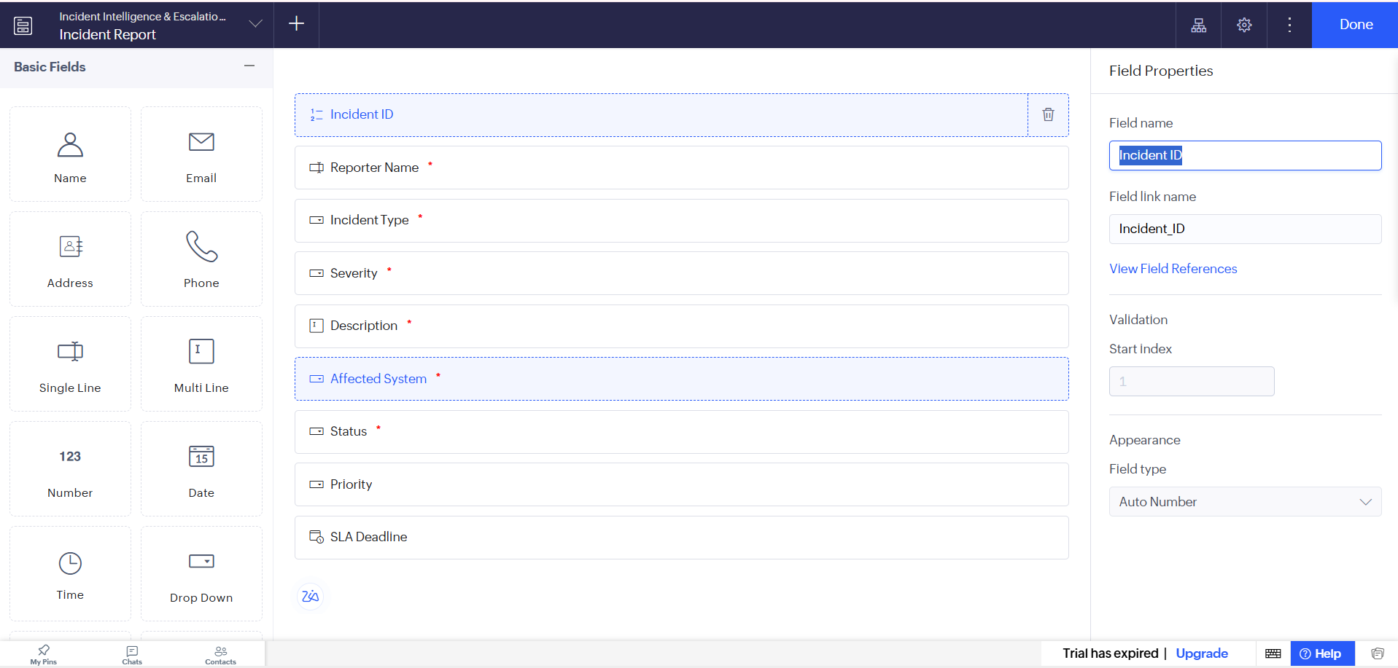
Figure 5.2: Incident Report Form in the Form Builder

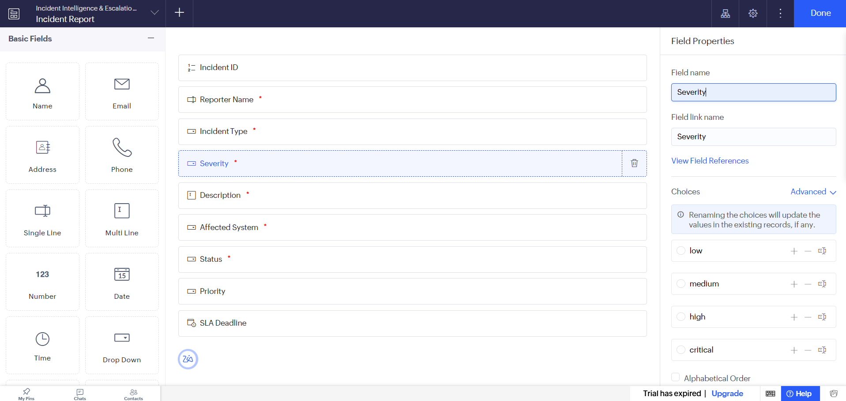
Figure 5.3: Incident Report Form in Live Mode

5.3 Reports
Table 5.1: Reports Implemented
Report Name | Type | Source Form | Filter / Grouping / Sorting | Custom Actions | Roles
All Incident Reports | List | Incident Report | All records; review by Incident ID | Open record | Analyst / Manager / Admin
Critical Incidents Report | Filtered list | Incident Report | Severity is critical | Open record | Analyst / Manager
Open Incidents Report | Filtered list | Incident Report | Status is New | Open record | Analyst / Manager
Incident Investigation Report | List | Incident Investigation | Investigation records | Open record | Analyst / Manager
Incident Resolution Report | List | Incident Resolution | Resolution records | Open record | Analyst / Manager

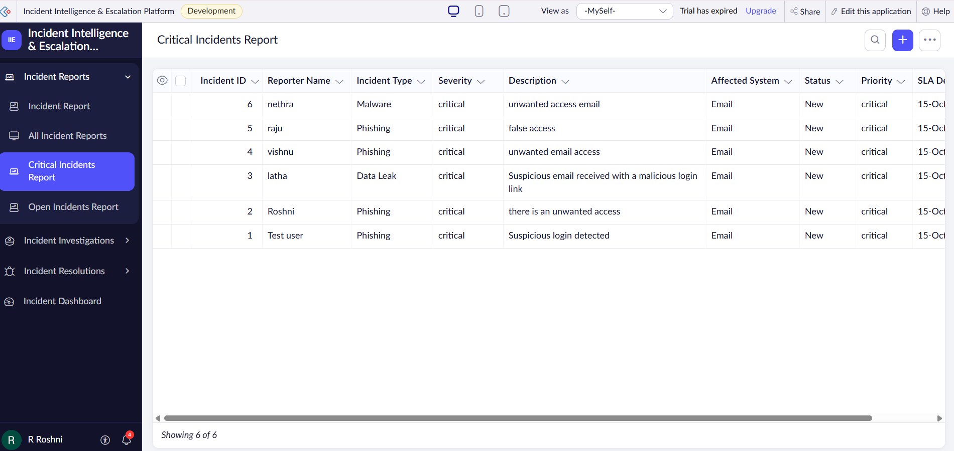
Figure 5.4: Critical Incidents Report

5.4 Pages and Dashboards
The dashboard page contains an Incident Status Overview chart and incident analysis charts based on configured reports. The All Incident Reports, Critical Incidents Report, Open Incidents Report, Incident Investigation Report and Incident Resolution Report provide detailed record views. The dashboard is intended for analysts and managers to review the current incident workload.

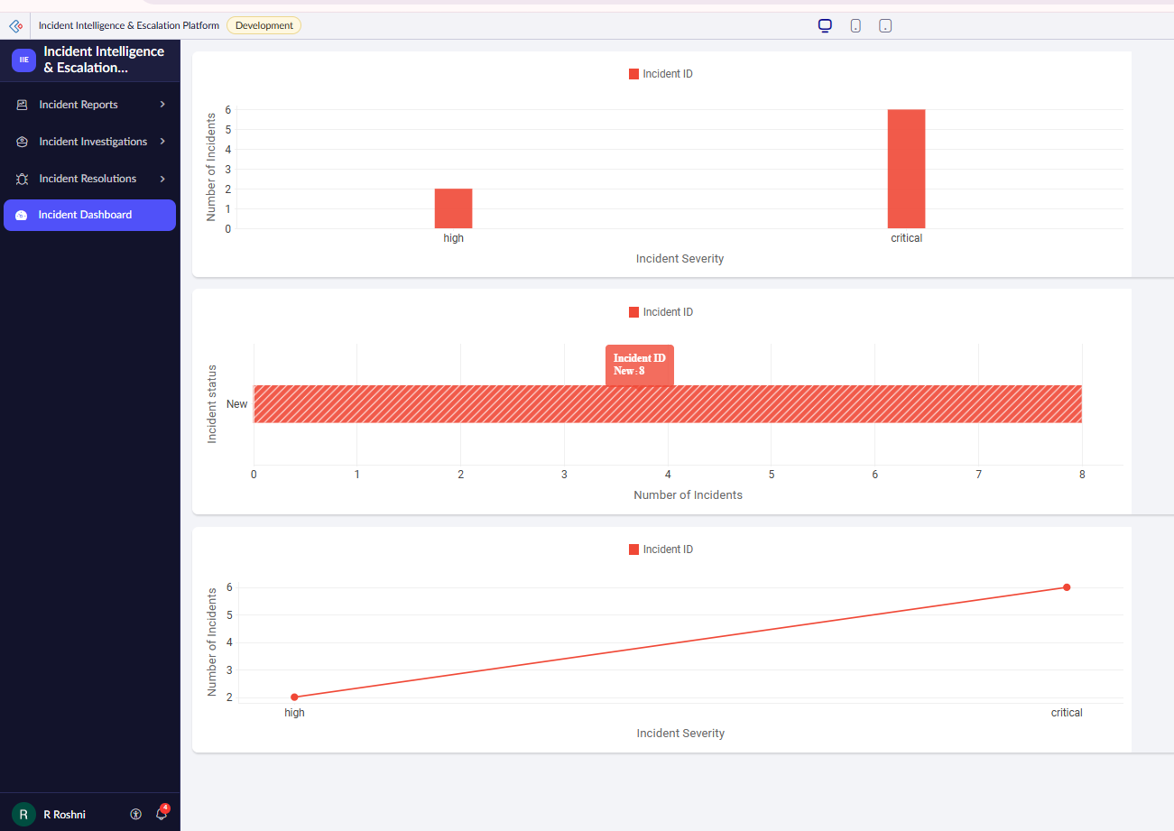
Figure 5.5: Incident Dashboard

5.5 Deluge Scripting
Table 5.2: Deluge Scripts Implemented
Script ID | Location / Trigger | Purpose | Deluge Concepts Used
DS-01 | Incident Report → On Validate / Created or Edited | Assign priority and SLA deadline based on severity | if / else-if; zoho.currenttime; addHour
DS-02 | Incident Resolution workflow | Send escalation email when checkbox is selected | Workflow condition; sendmail
DS-03 | Function: check_sla_breach | Find unresolved incidents whose SLA deadline has passed and send alert | Criteria fetch; for each; sendmail
DS-04 | Not implemented | No batch workflow in this prototype | —
Configured project scope | Configured project scope | Configured project scope | Configured project scope

Code 5.1: Deluge Script for Priority and SLA Calculation
// DS-01 | Form: Incident Report | Event: On Validate
// Purpose: Assign priority and SLA deadline from incident severity.
if(input.Severity == "critical")
{
input.Priority = "critical";
input.SLA_Deadline = zoho.currenttime.addHour(4);
}
else if(input.Severity == "high")
{
input.Priority = "high";
input.SLA_Deadline = zoho.currenttime.addHour(8);
}
else if(input.Severity == "medium")
{
input.Priority = "medium";
input.SLA_Deadline = zoho.currenttime.addHour(24);
}
else if(input.Severity == "low")
{
input.Priority = "low";
input.SLA_Deadline = zoho.currenttime.addHour(48);
}

Code 5.2: Escalation Notification Workflow Configuration
// DS-02 | Incident Resolution workflow
// Configure the workflow condition: Escalation_Required is selected.
// The email notification action sends an alert to the configured recipient.
// This action was verified through the Creator workflow notification configuration.

The priority script compares the selected Severity value with the four configured categories. It assigns the corresponding Priority and calculates the SLA deadline by adding 4, 8, 24 or 48 hours to the current time. The escalation workflow checks the Escalation Required field and sends an email when the condition is true. The overdue function queries records that are not Resolved and whose SLA Deadline is earlier than the current time. The function executed successfully during testing; recurring schedule behaviour still requires final verification.

5.6 Workflows and Automation
Table 5.3: Workflows Implemented
Workflow Name | Type | Trigger / Event | Condition | Action(s) | Script Ref.
Calculate Incident Risk | Form workflow | Incident Report created or edited | Severity is critical/high/medium/low | Set Priority and SLA Deadline | DS-01
Escalation Notification | Form workflow | Incident Resolution submitted | Escalation Required is selected | Send email notification | DS-02
SLA Breach Check | Function / intended schedule | Function execution | Status is not Resolved and SLA Deadline is before current time | Send breach email for matching records | DS-03
SLA Breach Check | Deluge Function | Manual execution; schedule pending | Overdue unresolved records | Send breach email | DS-03
Configured project scope | Configured project scope | Configured project scope | Configured project scope | Configured project scope | Configured project scope

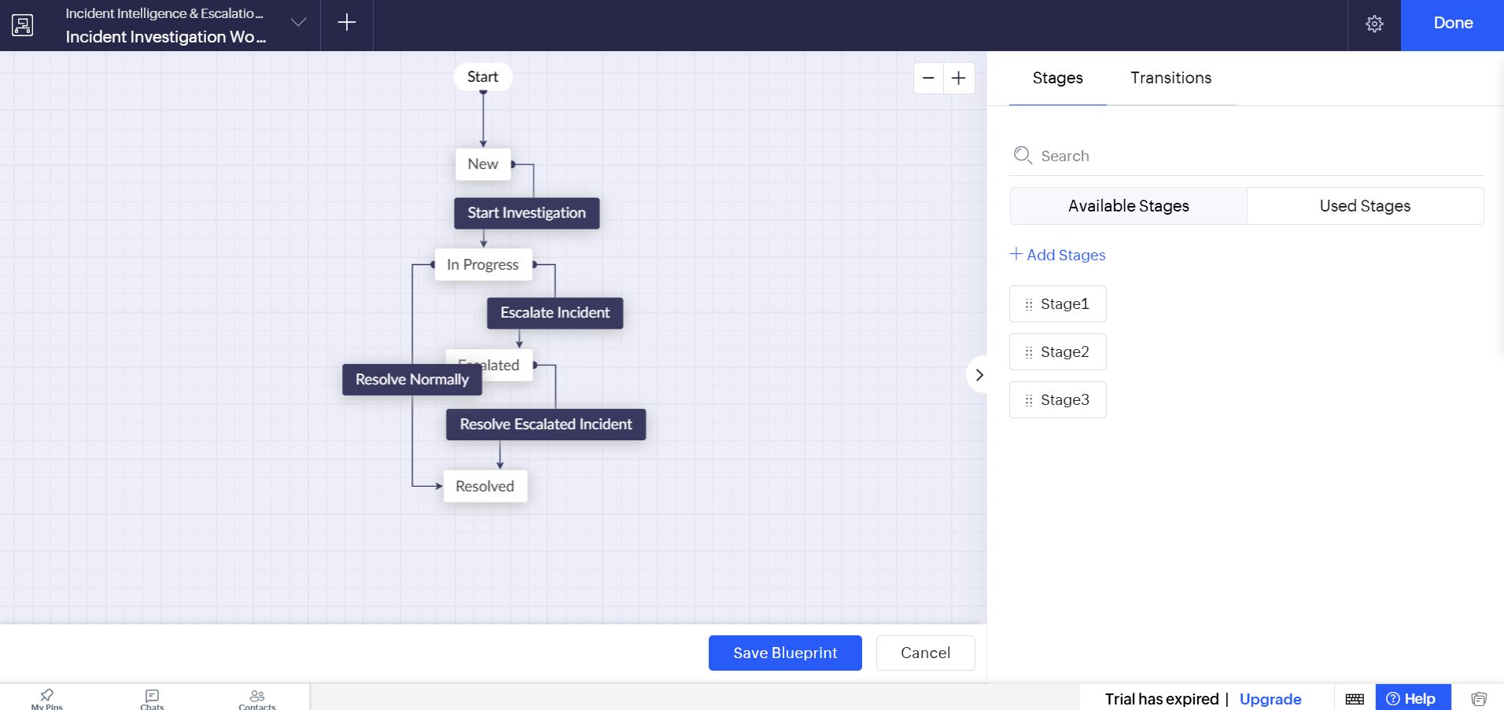
Figure 5.6: Incident Investigation Blueprint Configuration
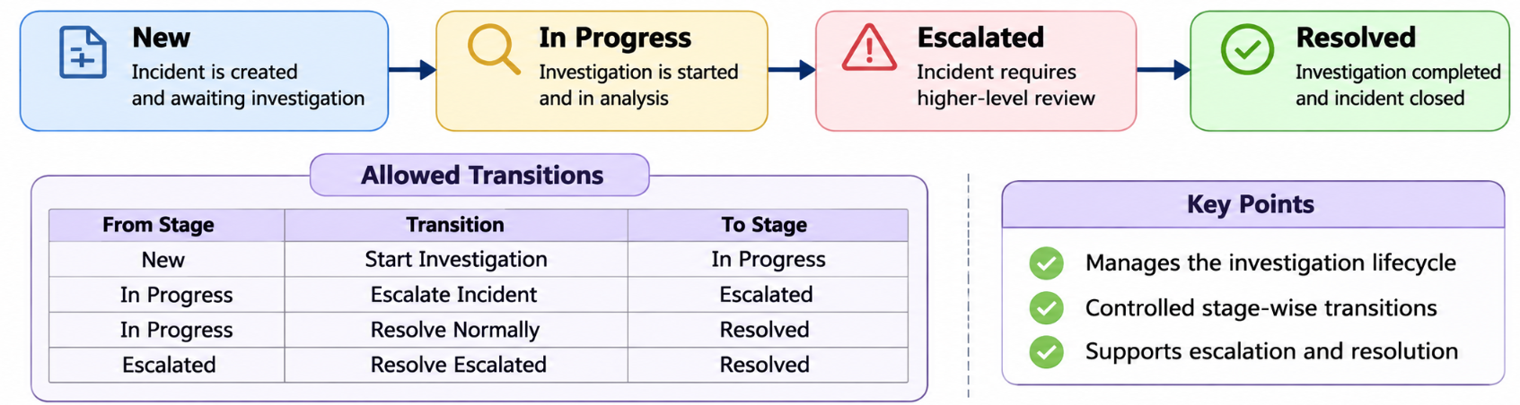
Investigation Blueprint Stages

5.7 Integrations
Table 5.4: Integrations Implemented
Integration | Service / Endpoint | Method | Authentication | Data Exchanged / Purpose
Email Notification | Zoho Creator built-in email action | Form workflow notification | Creator configured sender / recipient | Notify recipient when escalation is selected
External API | Not implemented | — | — | No external API data exchange in current prototype
Zoho CRM Sync | Not implemented | — | — | No CRM integration claimed

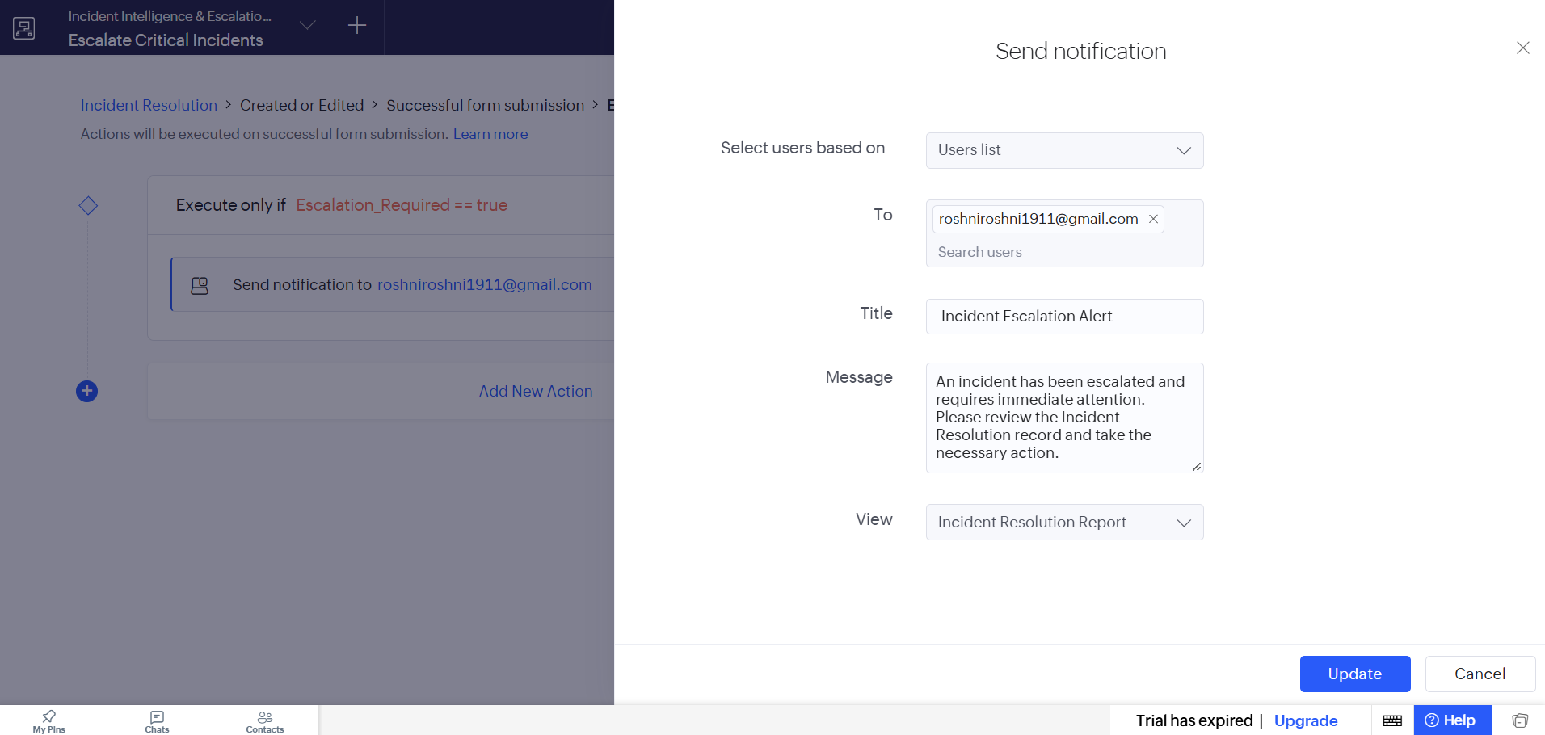
Figure 5.7: Configuration of Escalation Email Notification Workflow

5.8 User Management and Role-Based Access
Roles named Reporter, Security Analyst and Security Manager were created in the role hierarchy, and permission profiles named Reporter_Permission, Analyst_Permission and Manager_Permission were configured. During user addition, the role selector displayed CEO only. Therefore, the intended operational role assignment and access boundaries were not fully validated. The application should not be considered production-ready for sensitive incident data until this verification is completed.

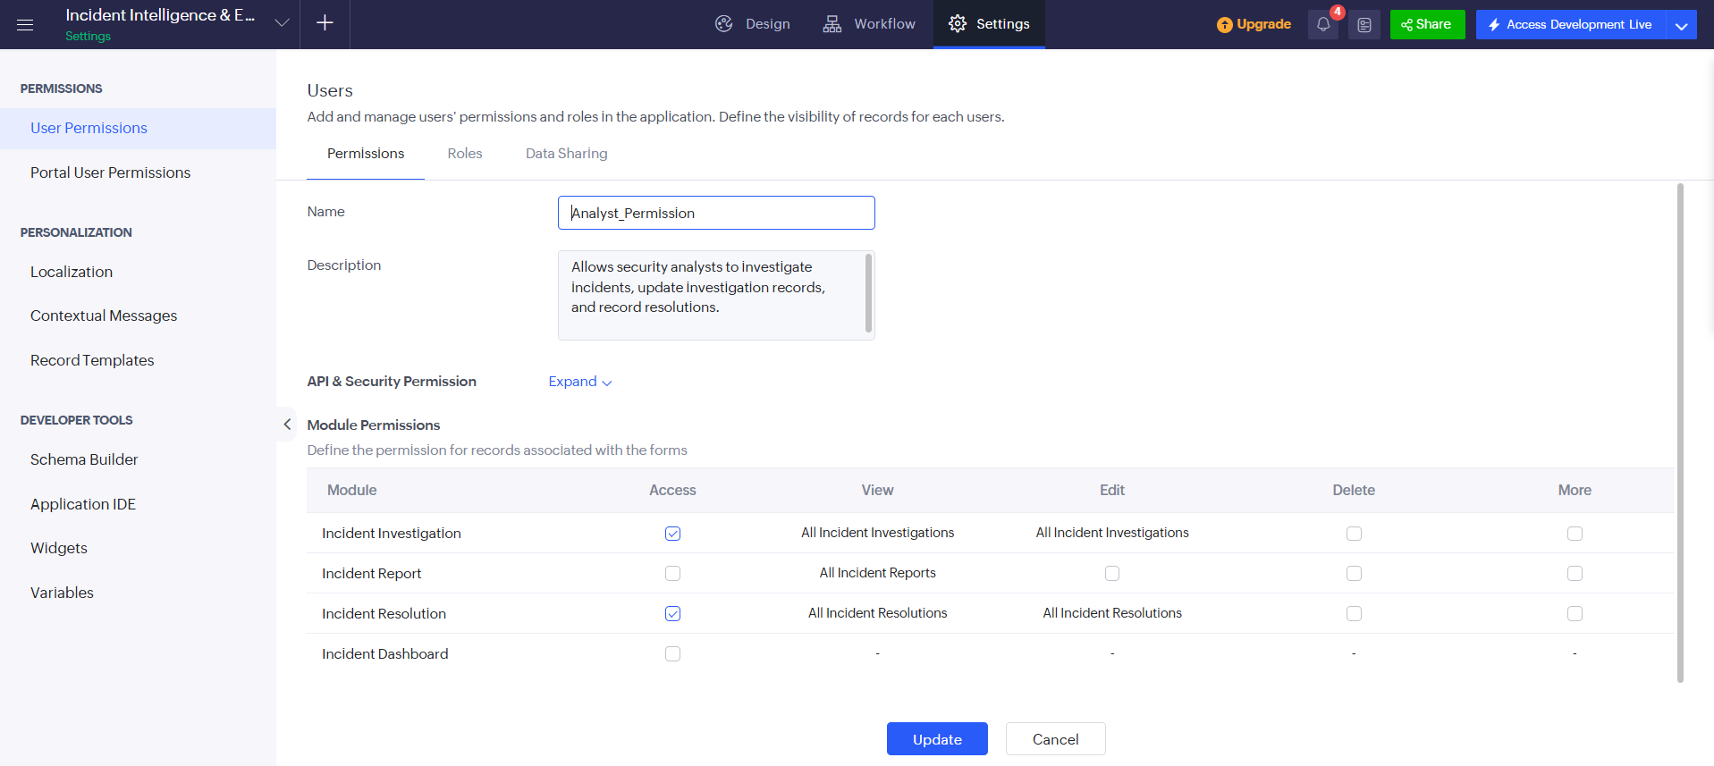
Figure 5.8: Roles and Permission Profiles Configuration
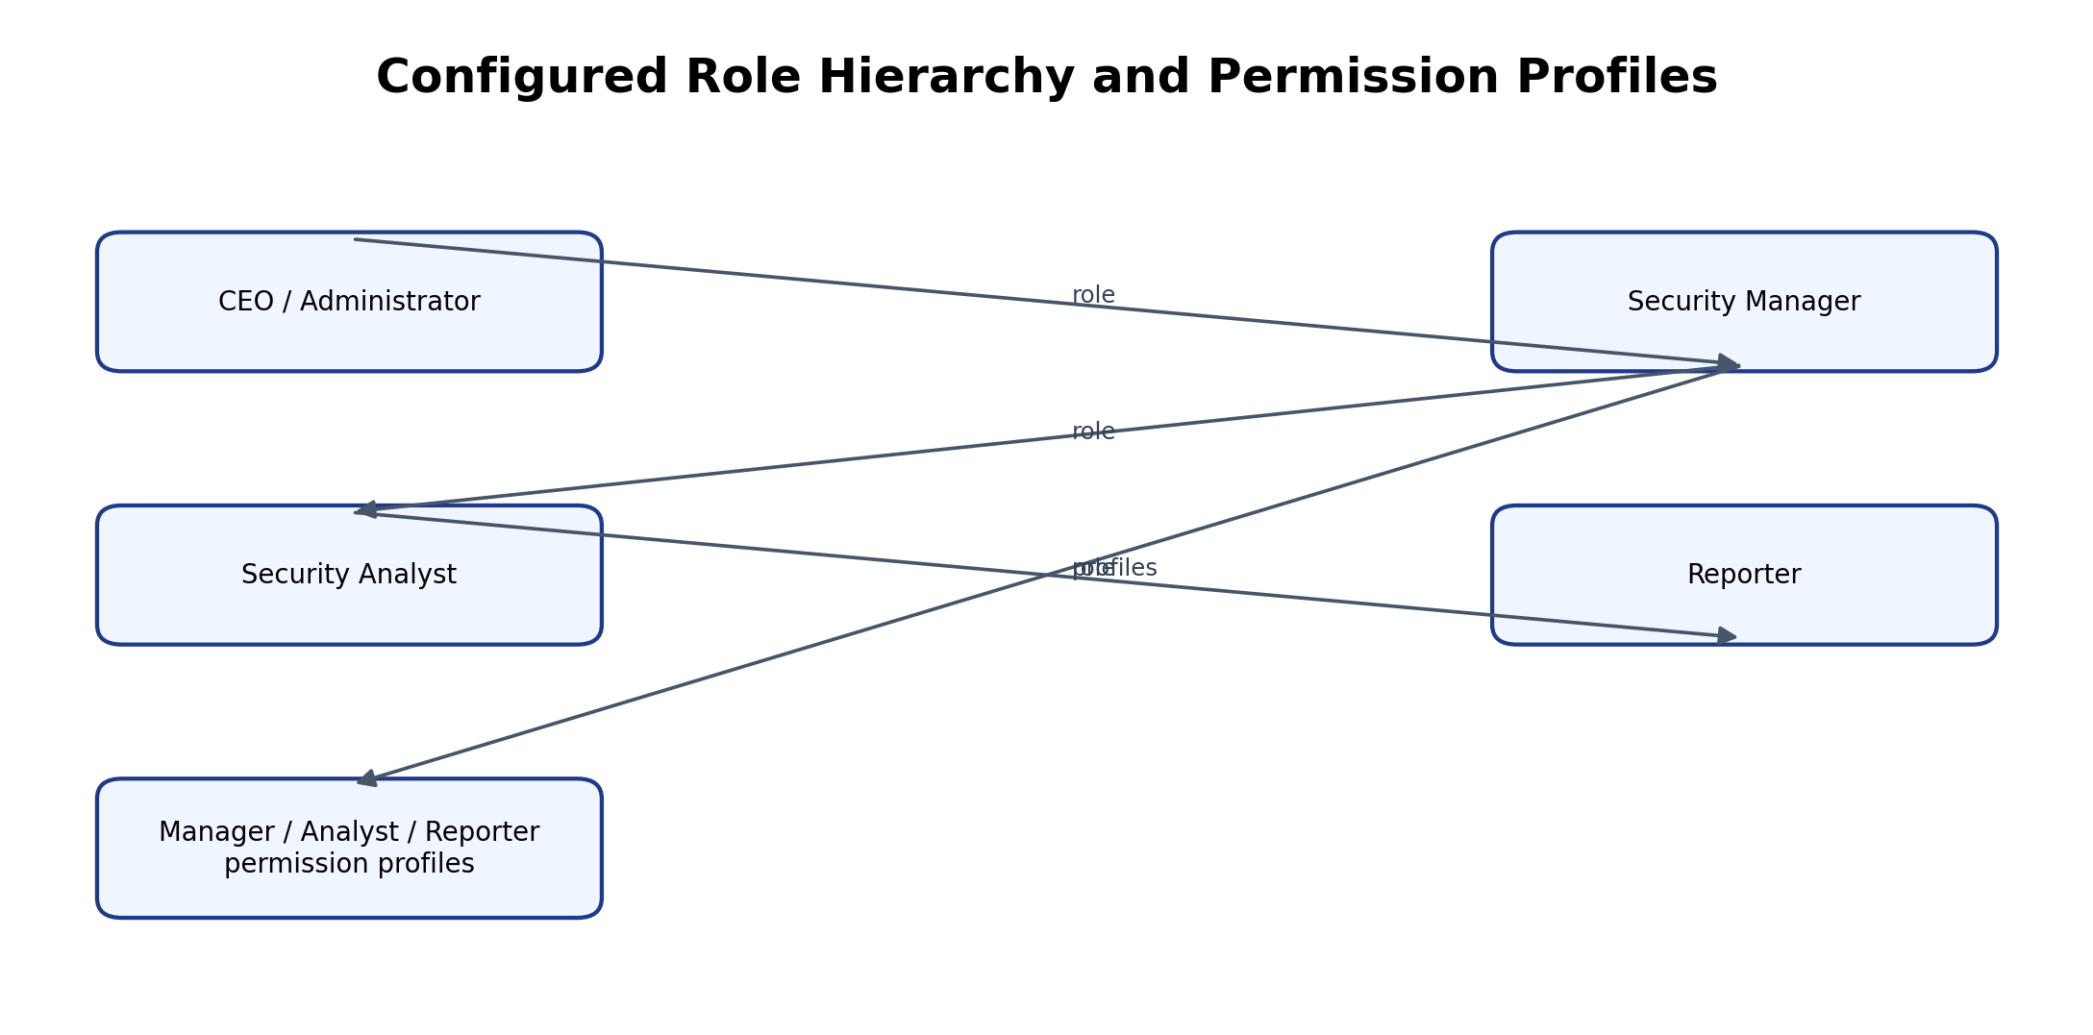

5.9 AI and Analytics Features
No Zia or external AI feature was implemented in the current prototype. The analytics capability is limited to Creator reports and dashboard charts that summarize incident records by status and severity. No machine-learning prediction, automated threat classification or AI-generated risk score is claimed. The risk score is entered as an investigation field by the analyst.

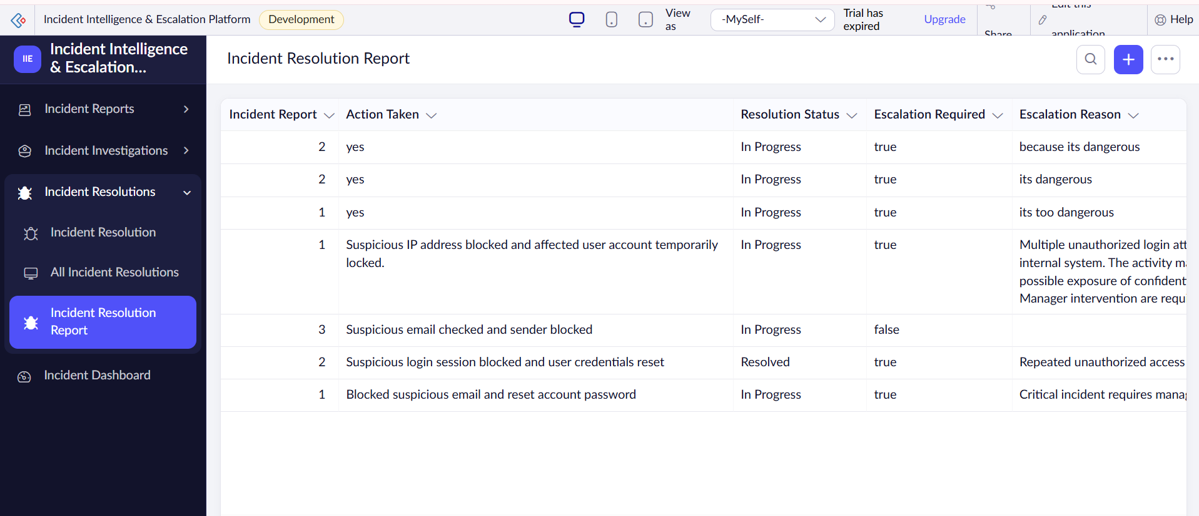
Figure 5.9: Analytics Through Creator Reports and Dashboard

5.10 Pro-Code Extension
No separate pro-code extension was implemented in the current prototype. The required functionality was achieved using Creator forms, reports, Deluge scripting, workflows and Blueprint configuration. A Catalyst service, custom JavaScript widget or Creator REST API may be considered if future requirements exceed the capabilities of the configured low-code application.

5.11 Mobile and Portal Access

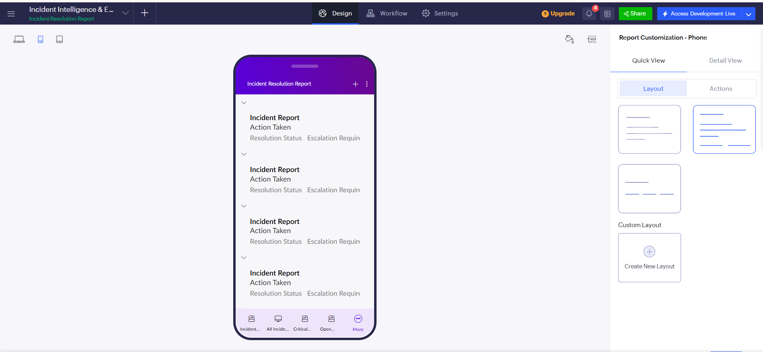
Figure 5.10: Creator Application Interface
CHAPTER 6

TESTING AND DEBUGGING

6.1 Testing Strategy
Testing was performed as functional checks on form submission, workflow results, email notification, overdue-record query, dashboard display and Blueprint controls. Positive and negative checks were used where possible. Testing was manual and limited to the configured prototype data. It did not include penetration testing, load testing or formal multi-user authorization testing.

6.2 Test Cases
Table 6.1: Test Cases
TC ID | FR Ref. | Test Description | Input / Steps | Expected Result | Actual Result | Status
TC-01 | FR-01 | Submit incident with required fields | Enter incident type, description, severity and affected system | Incident record is created | Record creation observed | Pass
TC-02 | FR-02 | Verify generated identifier | Create a new incident | Auto Number is generated | Incident IDs displayed | Pass
TC-03 | FR-03 | Critical severity rule | Submit severity critical | Priority critical; SLA +4 hours | Observed in saved record | Pass
TC-04 | FR-03 | High severity rule | Submit severity high | Priority high; SLA +8 hours | Observed in saved record | Pass
TC-05 | FR-03 | Medium severity rule | Submit severity medium | Priority medium; SLA +24 hours | Observed in saved record | Pass
TC-06 | FR-03 | Low severity rule | Submit severity low | Priority low; SLA +48 hours | Observed in saved record | Pass
TC-07 | FR-04 | Create linked investigation | Select Incident Report in lookup | Investigation links to selected incident | Record linked during test | Pass
TC-08 | FR-05 | Enter analyst and risk details | Enter analyst, risk score and notes | Values are stored | Values entered in test record | Pass
TC-09 | FR-06 | Start investigation transition | Use Start Investigation | Stage changes to In Progress | Transition control observed; final stage unconfirmed | Pending
TC-10 | FR-06 | Escalate investigation | Use Escalate Incident | Stage changes to Escalated | Not conclusively verified | Pending
TC-11 | FR-06 | Resolve investigation | Use Resolve transition | Stage changes to Resolved | Not conclusively verified | Pending
TC-12 | FR-07 | Escalation notification positive test | Select Escalation Required and submit | Email is sent | Email received | Pass
TC-13 | FR-07 | Escalation notification negative test | Leave checkbox unselected and submit | No escalation email | No email observed | Pass
TC-14 | FR-03 | Execute SLA breach function | Run check_sla_breach | Only overdue unresolved records selected | Execution output listed matching records | Pass
TC-15 | FR-03 | Verify scheduled SLA alerts | Run recurring schedule | Conditional email only for breached records | Schedule configuration has done | Pass

6.3 Debugging Deluge Scripts
Deluge scripts were tested through the Creator workflow and function execution facilities. Execution output and info statements were used to inspect current time and the records selected by the SLA query. During configuration, field link names and dropdown values were checked because exact matching is required by conditional statements. The SLA query was verified by observing the incident identifiers returned as overdue. A separate unconditional schedule email action must be removed or disabled before recurring conditional notifications can be considered verified.

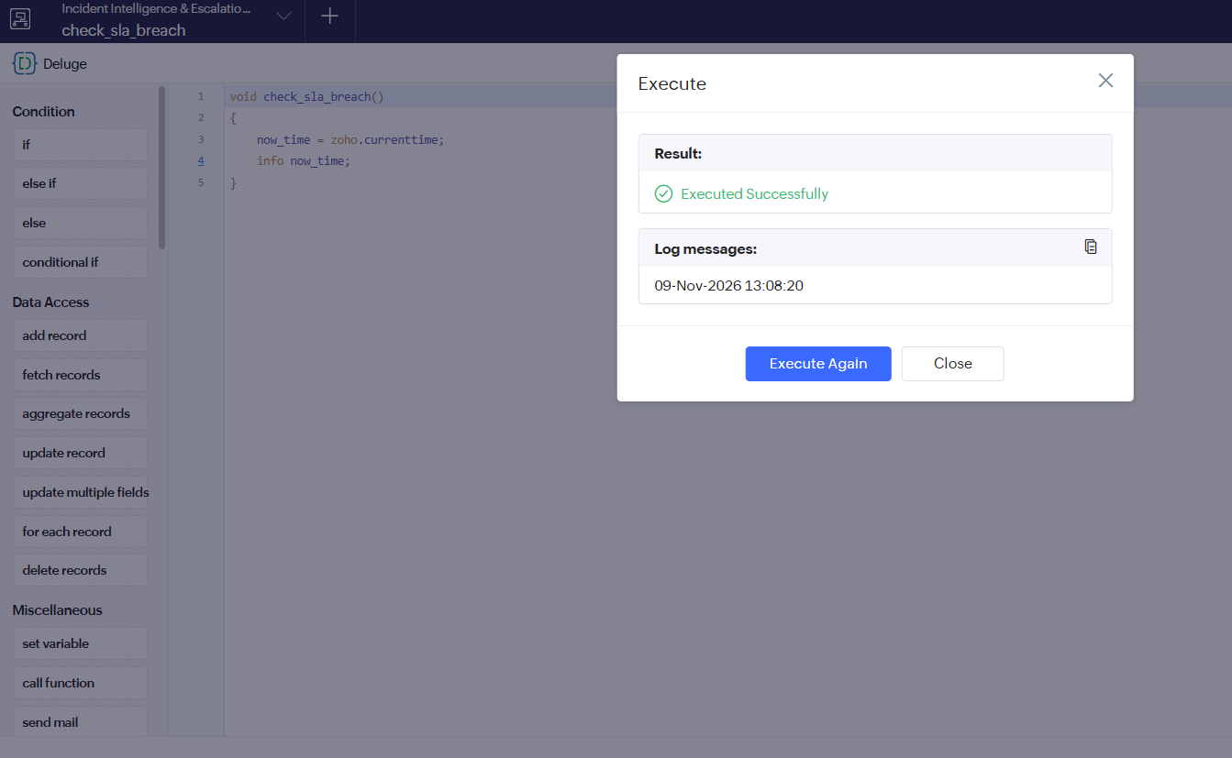
Figure 6.1: Deluge Function Execution Output for SLA Breach Check

6.4 Defect Log
Table 6.2: Defect Log
Bug ID | Description | Root Cause | Fix Applied | Status
BUG-01 | Priority and SLA fields initially did not populate consistently | Dropdown value / field link configuration mismatch | Verified exact values and field link names; tested workflow again | Resolved
BUG-02 | SLA email schedule could send independently of overdue condition | Separate unconditional Send Mail action remained in schedule configuration | Conditional function should be invoked by schedule; disable unconditional action | Open
BUG-03 | Operational roles not available in user-add dropdown | Role selector showed CEO only during test | Recheck role hierarchy and user assignment settings | Open

6.5 User Acceptance Testing
Table 6.3: User Acceptance Feedback
User | Role Tested | Feedback | Action Taken
Project developer | Administrator / configuration | Priority and SLA values were visible on tested incident records. | Verified workflow outputs for critical and high severity.
Test user | Reporter / analyst flow | Form and report navigation was understandable; role separation not fully tested. | Role assignment and permissions marked for further verification.
CHAPTER 7

DEPLOYMENT, SECURITY AND GOVERNANCE

7.1 Environments and Deployment Strategy
The application was developed and tested in the Zoho Creator hosted environment. The project configuration was validated using sample incident records. A formal Development–Stage–Production release pipeline, production publishing and rollback procedure were not fully demonstrated during this prototype. Before production use, the application owner should verify environment availability under the selected Creator plan, publish an approved version, document release notes and retain a rollback copy.

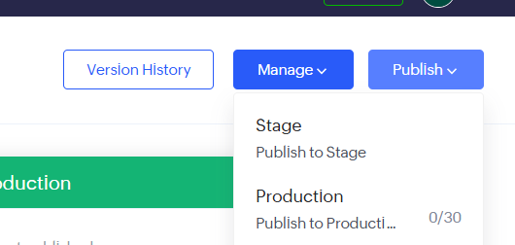
Figure 7.1: Zoho Creator Application Configuration Evidence
Table 7.1: Deployment Checklist
S.No. | Checklist Item | Done (✓)
1 | Application created and forms configured | ✓
2 | Lookup relationships configured | ✓
3 | Severity-based priority and SLA calculation workflow configured and tested | ✓
4 | Escalation email workflow tested with selected and unselected cases | ✓
5 | Filtered reports and dashboard charts configured | ✓
6 | Blueprint stages and transition options configured | ✓
7 | Reporter, Security Analyst and Security Manager roles and permission profiles created | ✓
8 | SLA breach function executed and overdue-record email verified | ✓

7.2 Performance Optimisation

Table 7.2: Performance Optimisation Results
Optimisation Applied | Component | Before | After | Improvement
Criteria-based overdue query | DS-03 | Not measured | Criteria filters unresolved incidents past deadline | No benchmark claimed
Filtered incident reports | Creator reports | All records | Severity / status filters configured | Improved focused review
Configured project scope | Configured project scope | Configured project scope | Configured project scope | Configured project scope

7.3 Security Features
Table 7.3: Security Controls Implemented
Security Control | Where Applied | Threat Mitigated
Role hierarchy and permission profiles | Zoho Creator user management | Intended separation of reporter, analyst and manager access; not fully verified
Lookup relationships | Investigation and Resolution forms | Reduces incorrect association with unrelated incidents
Controlled workflow transitions | Incident Investigation Blueprint | Reduces out-of-sequence process updates
Email notification | Incident Resolution workflow | Prompts attention when escalation is selected

7.4 Governance and Administration
Governance practices for a production deployment should include controlled administrator access, clear naming conventions, periodic review of users and permission profiles, export or backup of application data, and documentation of workflow changes. The current prototype uses named forms, reports, workflows and functions. Audit-trail configuration and backup/restore procedures should be checked and documented before operational use.

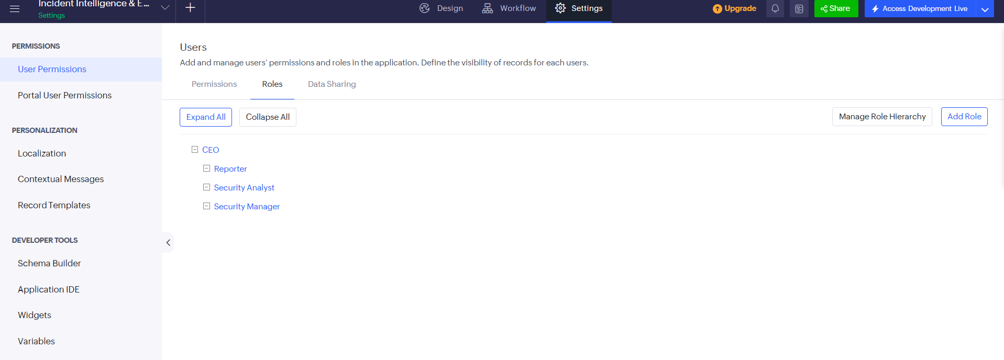
Figure 7.2: Role and Administration Configuration Evidence
CHAPTER 8

RESULTS AND DISCUSSION

8.1 Application Output
A sample incident scenario begins when a reporter submits a suspicious-login event. The Incident Report form generates an Incident ID and the severity-based workflow assigns priority and SLA deadline. An analyst creates an investigation record linked to the incident, enters a risk score and notes, and uses the Blueprint to move the investigation through the configured stages. If escalation is required, the analyst creates a resolution record with Escalation Required selected, causing the configured email notification to be sent. The incident can then be reviewed through the investigation, resolution and dashboard reports.

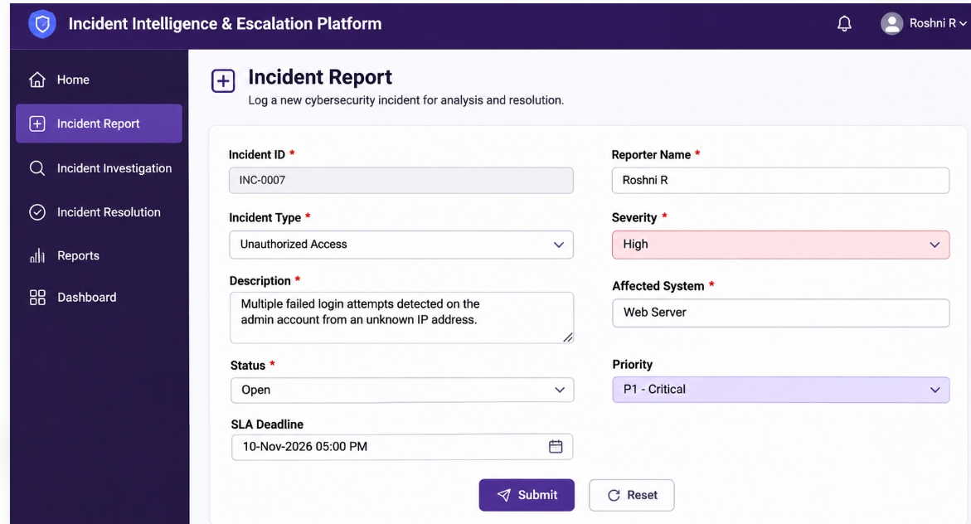
Figure 8.1: Scenario Step 1 – Incident Submission

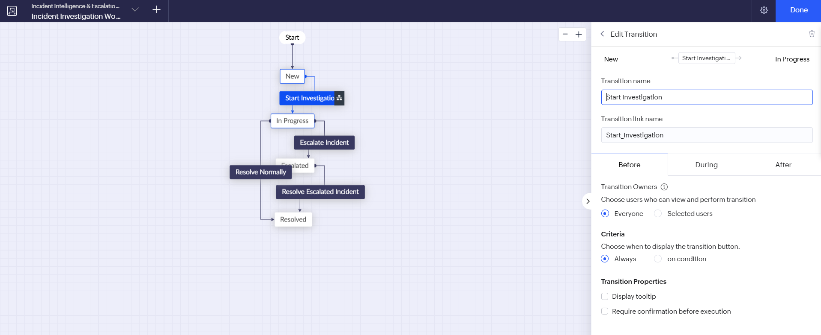
Figure 8.2: Scenario Step 2 – Incident Investigation and Escalation

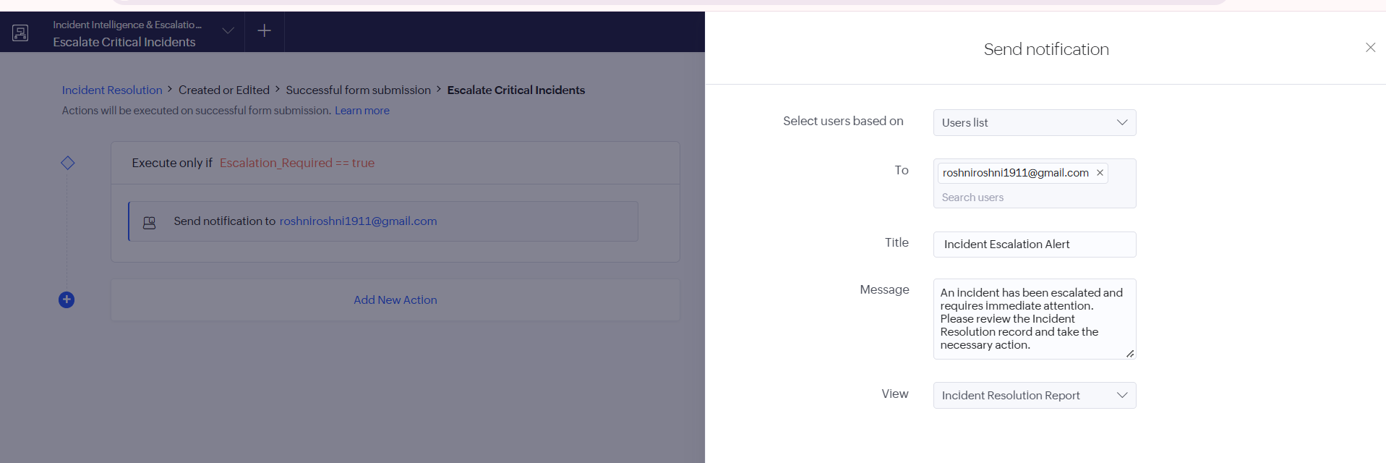
Figure 8.3: Scenario Step 3 – Incident Resolution and Reporting

8.2 Achievement of Objectives
Table 8.1: Mapping of Objectives to Outcomes
Objective (Sec. 1.3) | Implemented Through | Outcome / Evidence
Structured incident data | Incident Report / Investigation / Resolution forms | Three forms created and lookup links configured.
Automated priority and SLA | DS-01 workflow | Critical and high test records showed matching priority and deadline.
Escalation notification | DS-02 workflow | Email received for selected escalation; negative test did not send.
Monitoring and reporting | Reports and dashboard | Configured reports and charts displayed record counts.
Investigation lifecycle | Blueprint | Stages and transitions configured; stage completion needs final verification.

8.3 Comparison with the Existing System
Table 8.2: Existing System versus Proposed Application
Parameter | Existing System | Proposed Application | Improvement
Incident record keeping | Separate messages / spreadsheets | Linked Creator forms | Centralized structured records
Priority and deadline | Manual judgement and reminders | Severity-based Deluge workflow | Consistent initial target assignment
Escalation | Manual contact | Checkbox-triggered email workflow | Automated notification for selected escalation
Reporting | Manual filtering and counting | Filtered reports and dashboard charts | Faster overview of recorded incidents

8.4 Limitations of the Low-Code Approach
The prototype is constrained by the features and permissions available in the selected Zoho Creator environment. Custom interface behaviour may require page scripting or a pro-code extension. The current application does not ingest alerts directly from endpoint, firewall or SIEM tools. Role creation was completed, but assignment and access isolation for Reporter, Security Analyst and Security Manager were not fully verified. The SLA breach function executed and returned matching records, but the recurring schedule must invoke the conditional function and must not retain a separate unconditional email action.

8.5 Reflection on the No-Code → Low-Code → Pro-Code Spectrum
The application spans the no-code, low-code and pro-code spectrum. Form creation, lookup configuration, report filters, charts, roles and Blueprint stages are primarily visual no-code configuration. Conditional priority and SLA logic, overdue-record selection and email message construction use low-code Deluge scripting. A future integration with external threat feeds, advanced analytics or a custom portal could require pro-code services or APIs.
CHAPTER 9

CONCLUSION AND FUTURE ENHANCEMENTS

9.1 Conclusion
The Incident Intelligence and Escalation Platform demonstrates a low-code approach to organizing cybersecurity incident handling. It combines linked incident, investigation and resolution forms with severity-based priority and SLA calculation, escalation email notification, Blueprint process stages, filtered reports and dashboard charts. Functional checks confirmed key behaviours for tested records. The prototype provides a foundation for a more complete incident coordination application, subject to final role-based access and scheduled SLA verification.

9.2 Future Enhancements
- Implement a verified recurring SLA schedule with duplicate-alert prevention and escalation reminders.
- Add secure evidence attachments, audit history and role-specific record access.
- Integrate validated alerts from security monitoring tools and add incident trend analytics.

9.3 Learning Outcomes and Career Relevance
This project provided practical experience in low-code application design, data modelling, form configuration, lookup relationships, Deluge scripting, workflow automation, Blueprint process modelling, reporting and access-control planning. These skills are relevant to low-code development, business process automation, application support and solutions engineering. It also highlighted the importance of testing permissions and scheduled automation before using an application with sensitive operational data.

REFERENCES
[1] National Institute of Standards and Technology, Computer Security Incident Handling Guide, NIST Special Publication 800-61 Revision 2, Gaithersburg, MD, USA, Aug. 2012.
[2] National Institute of Standards and Technology, The NIST Cybersecurity Framework (CSF) 2.0, NIST CSWP 29, Gaithersburg, MD, USA, Feb. 2024.
[3] Zoho Corporation, “Zoho Creator Help,” Zoho Corporation. [Online]. Available: https://www.zoho.com/creator/help/. Accessed: Nov. 2, 2026.
[4] Zoho Corporation, “Deluge Scripting,” Zoho Creator Help. [Online]. Available: https://www.zoho.com/deluge/help/. Accessed: Nov. 2, 2026.
[5] Zoho Corporation, “Workflows in Zoho Creator,” Zoho Creator Help. [Online]. Available: https://www.zoho.com/creator/help/application/workflows/. Accessed: Nov. 2, 2026.
[6] Zoho Corporation, “Blueprint in Zoho Creator,” Zoho Creator Help. [Online]. Available: https://www.zoho.com/creator/help/blueprint/. Accessed: Nov. 2, 2026.
[7] International Organization for Standardization, ISO/IEC 27035-1:2016, Information technology—Security techniques—Information security incident management—Part 1: Principles of incident management, Geneva, Switzerland, 2016.

APPENDIX A – ZOHO CREATOR FEATURE COVERAGE CHECKLIST
Table A.1: Feature Coverage Checklist
Unit | Zoho Creator Feature | Done | Where in the Application | Report Section | Figure / Code No.
I | Application created and sections organised | Y | Incident Intelligence application | 5.1 | Fig. 5.1
II | Forms with multiple field types | Y | Incident Report / Investigation / Resolution | 5.2 | Fig. 5.2–5.3
II | Lookup field relationships | Y | Investigation and Resolution lookup fields | 4.2, 5.2 | Fig. 4.2
II | Required fields and dropdown configuration | Y | Incident Report and related forms | 5.2 | Fig. 5.2–5.3
II | List reports with filters | Y | Critical Incidents and Open Incidents Reports | 5.3 | Fig. 5.4
II | Dashboard page and charts | Y | Incident Status Overview dashboard | 5.4 | Fig. 5.5
II | Deluge form workflow | Y | Calculate Incident Risk | 5.5 | Code 5.1
II | Deluge custom function | Y | check_sla_breach | 5.5 | Code 5.2
II | Blueprint stages and transitions configured | Y | Incident Investigation Blueprint | 5.6 | Fig. 5.6
III | Role hierarchy and permission profiles created | Y | Reporter / Security Analyst / Security Manager | 5.8 | Fig. 5.8
III | Conditional email notification | Y | Incident Resolution escalation workflow | 5.6 | Fig. 5.7 / DS-02
VI | Functional test cases executed | Y | Incident submission, identifier, critical/high SLA, lookup, email and function tests | 6.2 | Table 6.1

Total verified feature items documented in this checklist: 12. Each listed item is marked Done (Y).
[1] National Institute of Standards and Technology, Computer Security Incident Handling Guide, NIST Special Publication 800-61 Revision 2, Gaithersburg, MD, USA, Aug. 2012.[2] National Institute of Standards and Technology, The NIST Cybersecurity Framework (CSF) 2.0, NIST CSWP 29, Gaithersburg, MD, USA, Feb. 2024.[3] Zoho Corporation, “Zoho Creator Help,” Zoho Corporation. [Online]. Available: https://www.zoho.com/creator/help/. Accessed: Nov. 2, 2026.[4] Zoho Corporation, “Deluge Scripting,” Zoho Creator Help. [Online]. Available: https://www.zoho.com/deluge/help/. Accessed: Nov. 2, 2026.
CO | Course Outcome Statement | Evidenced In | Self-Assessed Level | Examiner Level
CO1 | Explain principles, architecture and business value of low-code application development. | Ch. 1, 2, 4 | 3 – High
CO2 | Develop business applications using Zoho Creator forms, reports, workflows and Deluge. | Ch. 4, 5, 6 | 3 – High
CO3 | Apply integrations, user management and permission concepts. | Ch. 4.6, 5.7–5.8, 7 | 2 – Medium
CO4 | Test, debug, deploy and govern a low-code application. | Ch. 6, 7, 8 | 2 – Medium
CO5 | Evaluate low-code limits and future pro-code opportunities. | Ch. 8, 9 | 3 – High
[5] Zoho Corporation, “Workflows in Zoho Creator,” Zoho Creator Help. [Online]. Available: https://www.zoho.com/creator/help/application/workflows/. Accessed: Nov. 2, 2026. [6] Zoho Corporation, “Blueprint in Zoho Creator,” Zoho Creator Help. [Online]. Available: https://www.zoho.com/creator/help/blueprint/. Accessed: Nov. 2, 2026. [7] International Organization for Standardization, ISO/IEC 27035-1:2016, Information technology—Security techniques—Information security incident management—Part 1: Principles of incident management, Geneva, Switzerland, 2016.
C.1 Incident Report – Calculate Incident Risk
// DS-01 | Form: Incident Report | Event: On Validate
// Purpose: Assign priority and SLA deadline from incident severity.
if(input.Severity == "critical")
{
input.Priority = "critical";
input.SLA_Deadline = zoho.currenttime.addHour(4);
}
else if(input.Severity == "high")
{
input.Priority = "high";
input.SLA_Deadline = zoho.currenttime.addHour(8);
}
else if(input.Severity == "medium")
{
input.Priority = "medium";
input.SLA_Deadline = zoho.currenttime.addHour(24);
}
else if(input.Severity == "low")
{
input.Priority = "low";
input.SLA_Deadline = zoho.currenttime.addHour(48);
}

C.2 Function – check_sla_breach
// DS-03 | Function: check_sla_breach | Purpose: Find overdue unresolved incidents.
nowTime = zoho.currenttime;
incidents = Incident_Report[Status != "Resolved" && SLA_Deadline < nowTime];
for each incident in incidents
{
sendmail
[
from : zoho.adminuserid
to : "configured-recipient@example.com"
subject : "SLA Deadline Breached - Incident " + incident.Incident_ID
message : "Incident ID " + incident.Incident_ID + " has exceeded its SLA deadline. Severity: " + incident.Severity + ". Please review the incident."
];
}

APPENDIX D – USER MANUAL

D.1 Accessing the Application
1. Open the Zoho Creator application URL in a supported browser.
2. Sign in using the user account created by the application administrator.
3. Select the Incident Dashboard to view charts and reports.
4. Use the Incident Report form to submit a new incident.

D.2 Instructions for Reporter
- 1. Open Incident Report and enter the reporter name, incident type, description, severity and affected system.
2. Submit the form and note the generated Incident ID, assigned priority and SLA deadline.
- 3. Review the incident record and provide additional details if requested by the analyst.

D.3 Instructions for Security Analyst
- 1. Open the relevant incident record and create an Incident Investigation record using the Incident Report lookup.
2. Enter Assigned Analyst, Risk Score and Investigation Notes, then use the Blueprint transition to start investigation.
- 3. Update investigation notes and select Escalate or Resolve according to the outcome. For escalation, create a resolution record and select Escalation Required.S

APPENDIX E – EVALUATION RUBRIC
(For Examiner Use Only)
Student Name | Roshni R | Register No. | 240701443
Project Title | Incident Intelligence and Escalation Platform | Date | 02 November 2026

Table E.1: Evaluation Rubric for the Individual Project
S.No. | Criterion | Indicators | Max. Marks | Marks Awarded
1 | Problem Definition & Requirement Analysis | Clarity of problem, measurable objectives, complete FR/NFR, use cases | 10
2 | System Design | Architecture, ER/data model, form specifications, workflow design, permission matrix | 10
3 | Forms, Reports & Pages | Variety of field types, lookups/subforms, report types, UI Builder dashboards | 15
4 | Deluge Scripting & Workflows | Correctness and depth of scripts; form, schedule, approval, Blueprint, batch workflows | 15
5 | Integration, RBAC & AI | Zoho/external integrations, connections, roles & permissions, Zia/analytics | 10
6 | Testing, Deployment, Security & Governance | Test coverage, environments, optimisation, security controls, audit | 10
7 | Live Demonstration | End-to-end working of the application across roles; feature checklist verified | 15
8 | Project Report | Adherence to template and format, clarity, figures, references | 5
9 | Viva-Voce | Understanding of the platform, design decisions and low-code concepts | 10
 | TOTAL |  | 100

Table E.2: Performance Level Descriptors
Level | % of Max. Marks | Descriptor
Excellent | 90–100 | Feature implemented completely, correctly and beyond the basic requirement; student explains design choices confidently.
Good | 70–89 | Feature implemented correctly with minor gaps; explanation adequate.
Satisfactory | 50–69 | Feature partially implemented or works only for the main path; limited explanation.
Needs Improvement | < 50 | Feature missing, non-functional or not understood by the student.

Signature of Internal Examiner  Name: ____________________ | Signature of External Examiner  Name: ____________________

APPENDIX F – VIVA-VOCE RECORD SHEET
(For Examiner Use Only)
Student Name | Roshni R | Register No. | 240701443
Department / Section | Computer Science and Engineering | Date of Viva | ________________
Application URL Verified | Yes / No | Demo Duration | ______ min
Table F.1: Viva-Voce Questions and Responses
Q.No. | Question / Topic Asked | Unit | Response (E / G / S / NI) | Remarks
1
2
3
4
5
6
7
8
E – Excellent G – Good S – Satisfactory NI – Needs Improvement
Table F.2: Marks Summary
Component | Max. Marks | Marks Awarded
Criteria 1–8 (Appendix E) | 90
Viva-Voce | 10
TOTAL | 100

Examiners’ Remarks:
____________________________________________________________________
____________________________________________________________________
INTERNAL EXAMINER  Name: ____________________ | EXTERNAL EXAMINER  Name: ____________________

